**Table of Contents**

1. Bar ----------------------------------------------------------------------------------------------------------- 3-32
   1. Column Chart
      1. What is Column Chart
      2. When to Use Column Chart
      3. Does the column chart needs dimensions and metrics (measures)
      4. Dimension in Column Chart
      5. Metrics in Column Chart
      6. Sample data
      7. Develop Column Chart
   2. Stacked Column Chart 8-12
   3. 100% Stacked Column Chart 13-17
   4. Bar Chart 18-22
   5. Stacked bar Chart 23-27
   6. 100% Stacked bar Chart 28-32
2. Table -----------------------------------------------------------------------------------------------------------
   1. Table Chart
      1. What is Table Chart
      2. When to Use Table Chart
      3. Does the Table chart needs dimensions and metrics (measures)
      4. Dimension in Table Chart
      5. Metrics in Table Chart
      6. Sample data
      7. Develop Table Chart
   2. Table with bar
   3. Table with heatmap
3. Scorecard -----------------------------------------------------------------------------------------------------------
   1. Scorecard chart
      1. What is Scorecard Chart
      2. When to Use Scorecard Chart
      3. Does the Scorecard chart needs dimensions and metrics (measures)
      4. Dimension in Scorecard Chart
      5. Metrics in Scorecard Chart
      6. Sample data
      7. Develop Scorecard Chart
   2. Scorecard with compact number
4. Pie -----------------------------------------------------------------------------------------------------------
   1. Pie Chart
      1. What is Pie chart
      2. When to Use Pie Chart
      3. Does the Pie chart needs dimensions and metrics (measures)
      4. Dimension in Pie Chart
      5. Metrics in Pie Chart
      6. Sample data
      7. Develop Pie Chart
   2. Doughnut Chart
5. Line -----------------------------------------------------------------------------------------------------------
   1. Combo Chart
   2. Stacked Combo Chart
   3. Line Chart
   4. Smoothed Line Chart
6. Time Series -----------------------------------------------------------------------------------------------------------
   1. Time series Chart
   2. Smoothed Time series Chart
7. Area -----------------------------------------------------------------------------------------------------------
   1. Stacked area Chart
   2. 100% Stacked area Chart
   3. Area Chart
8. Scatter -----------------------------------------------------------------------------------------------------------
   1. Scatter Chart
   2. Bubble Chart
9. Pivot Table -----------------------------------------------------------------------------------------------------------
   1. Pivot Table Chart
   2. Pivot Table with bar
   3. Pivot Table with heatmap
10. Bullet Chart ------------------------------------------------------------------------------------------------------------
11. Treemap Chart --------------------------------------------------------------------------------------------------------
12. Gauge -------------------------------------------------------------------------------------------------------------------

12.1 Gauge Chart

12.2 Gauge with Ranges

13 Google Map -------------------------------------------------------------------------------------------------------------

13.1 Bubble Map

13.2 Filled Map

13.3 Heat Map

14 Geo Chart -----------------------------------------------------------------------------------------------------------------

1. **Bar**

1.1 Column Chart

1.1.1- What is a Column chart?

Ans- A Column chart is a data visualization chart in which each category is represented by a rectangular block, where the height of the rectangle gives the required value. Column charts are also referred to as vertical bar charts.

1.1.2- When to use column chart?

Ans-Column chart is performed for comparison perspective in a large scale. Let’s take a business Scenario to understand it better.

Company xyz have sales data from Jan to Dec. They need to find the bestselling product of the year among all the branches of the company. Column chart can give the best comparative analysis for finding bestselling product based on sales.

1.1.3- Does the column chart needs dimensions and metrics?

Ans- Yes, Column chart needs both dimension and metrics where we can add only 1 dimension and 1 or more metrics. Along with metrics, we can add optional metrics as well based on our requirement. 1 dimension and 1 metric is mandatory and on the other side breakdown dimension and optional metric is optional.

1.1.4- In the column chart, what is a dimension represents?

Ans- In column chart, longer the bar means the greater the value it represents. So, one axis of the chart shows the specific categories being compared. The categories which are been used for comparison is known as dimension. Example- Product

1.1.5- In the column chart, what is a metrics(measures) represents?

Ans- In column chart, one axis is dimension, and the other axis represents a discrete value of the dimension. And that discrete value is known as measures. Example- Sales, Revenue etc.

1.1.6- How does sample data look?

Ans-

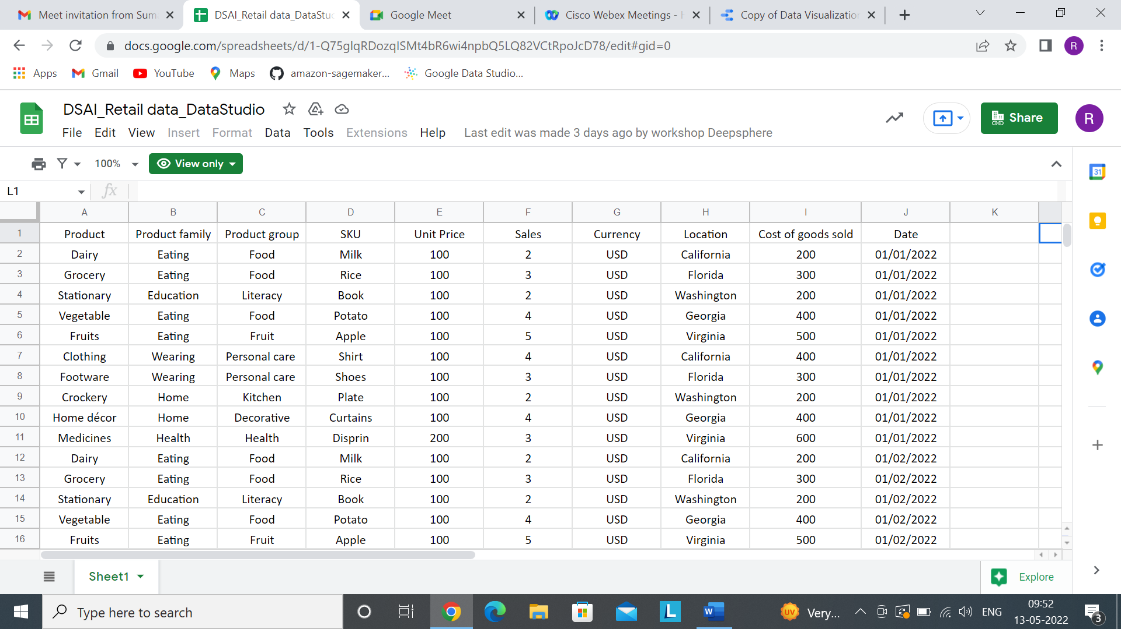

1.1.7- How to develop simple Column Chart?

Ans-

Step1- Add data to Report.

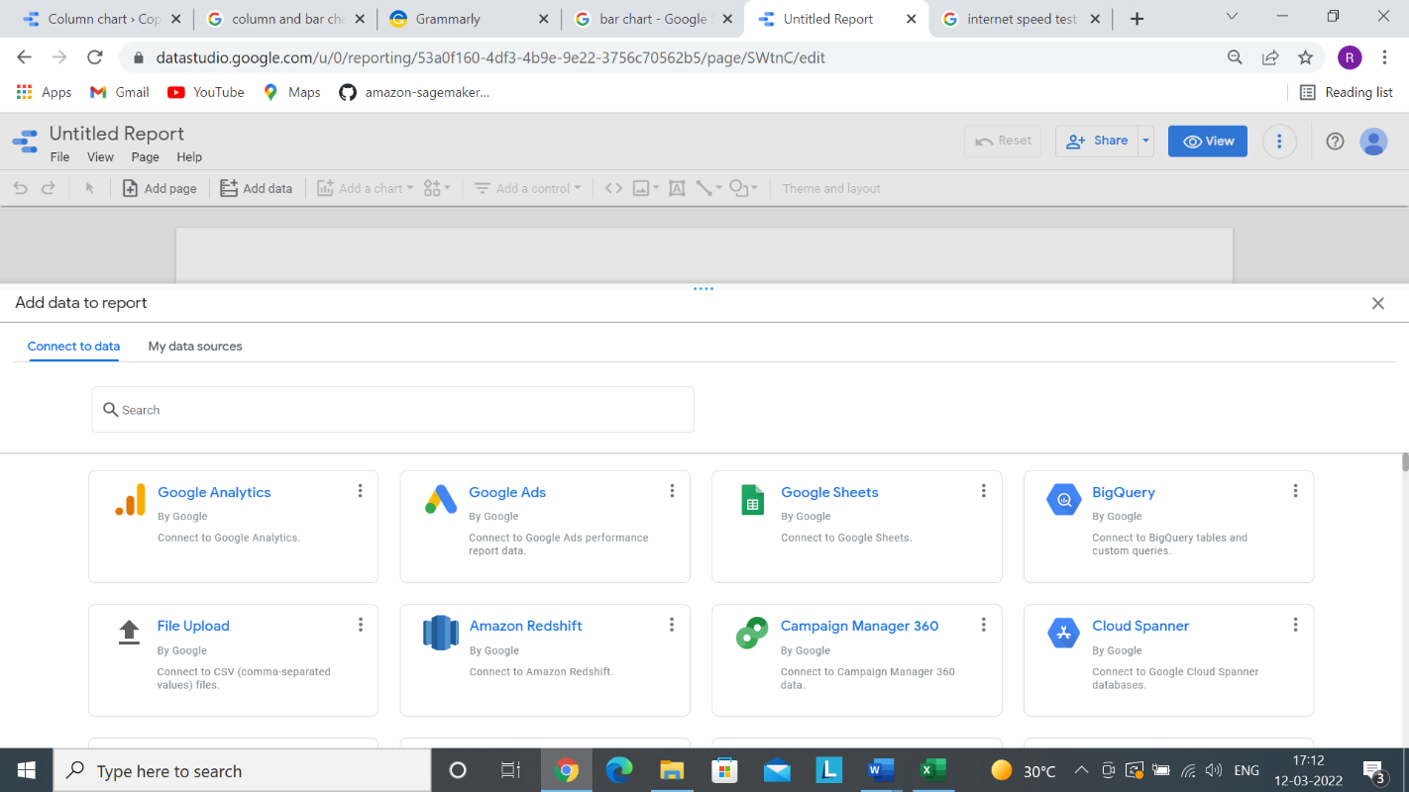

Step-2 Click on Add to Report

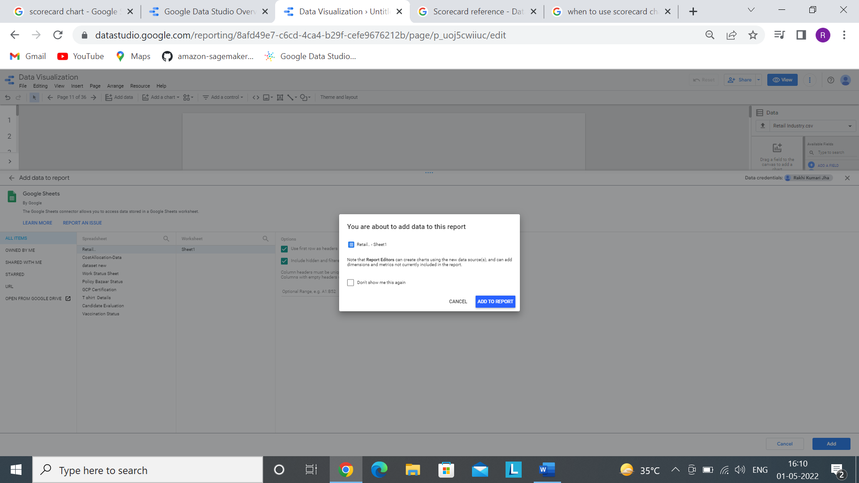

Step 3- Click on Add a Chart and select Column chart.

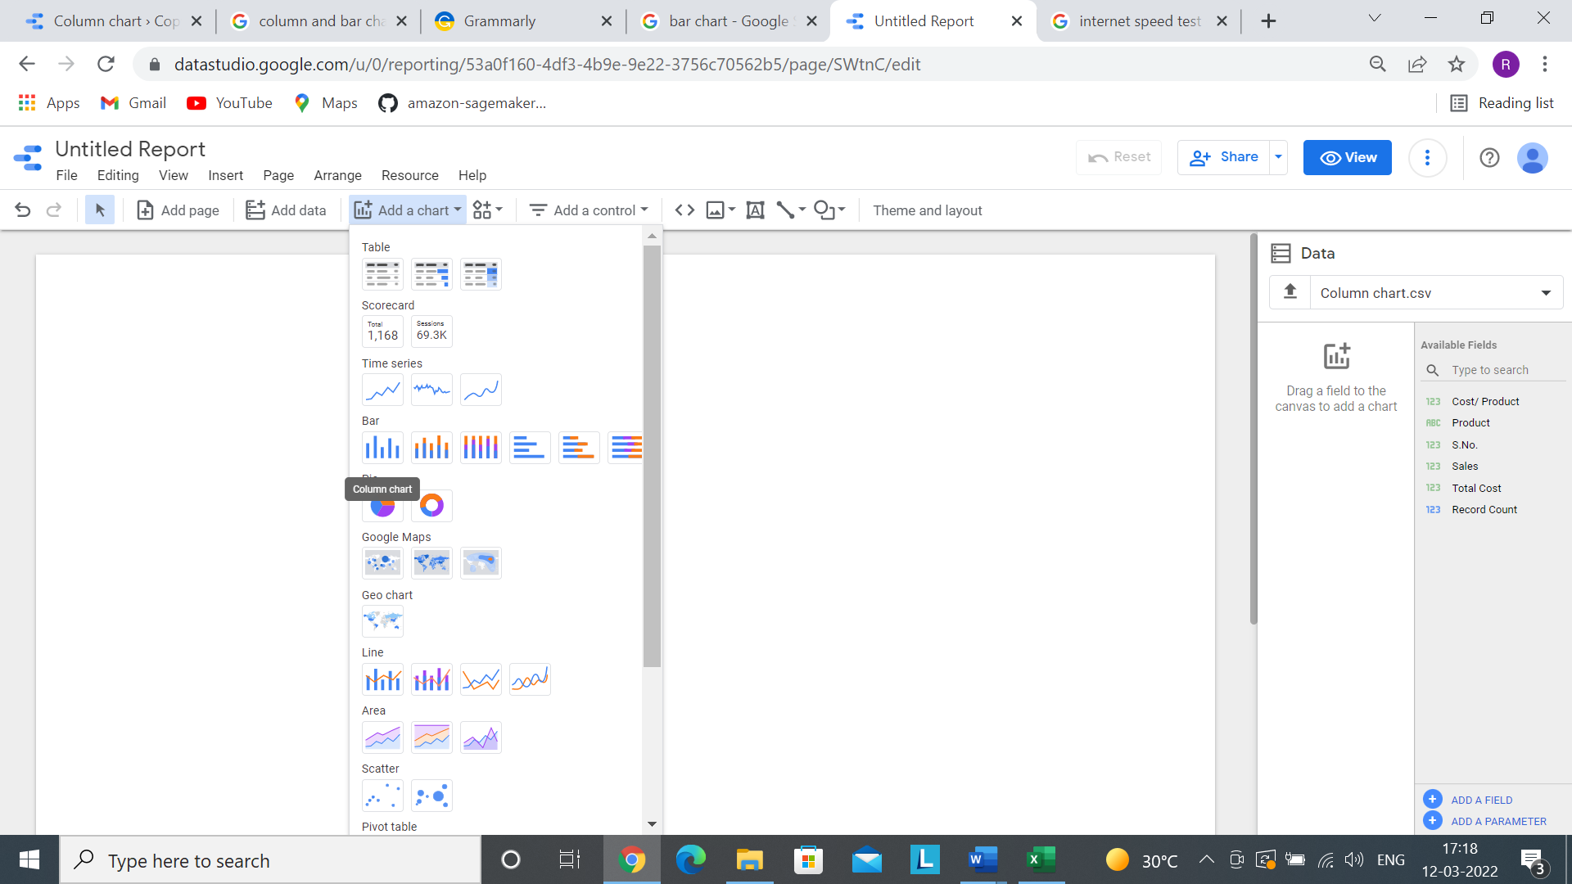

Step 4- **Creating Calculation field**

In this step, we are creating different calculation field that will be used in the entire document.

-----> Add a field

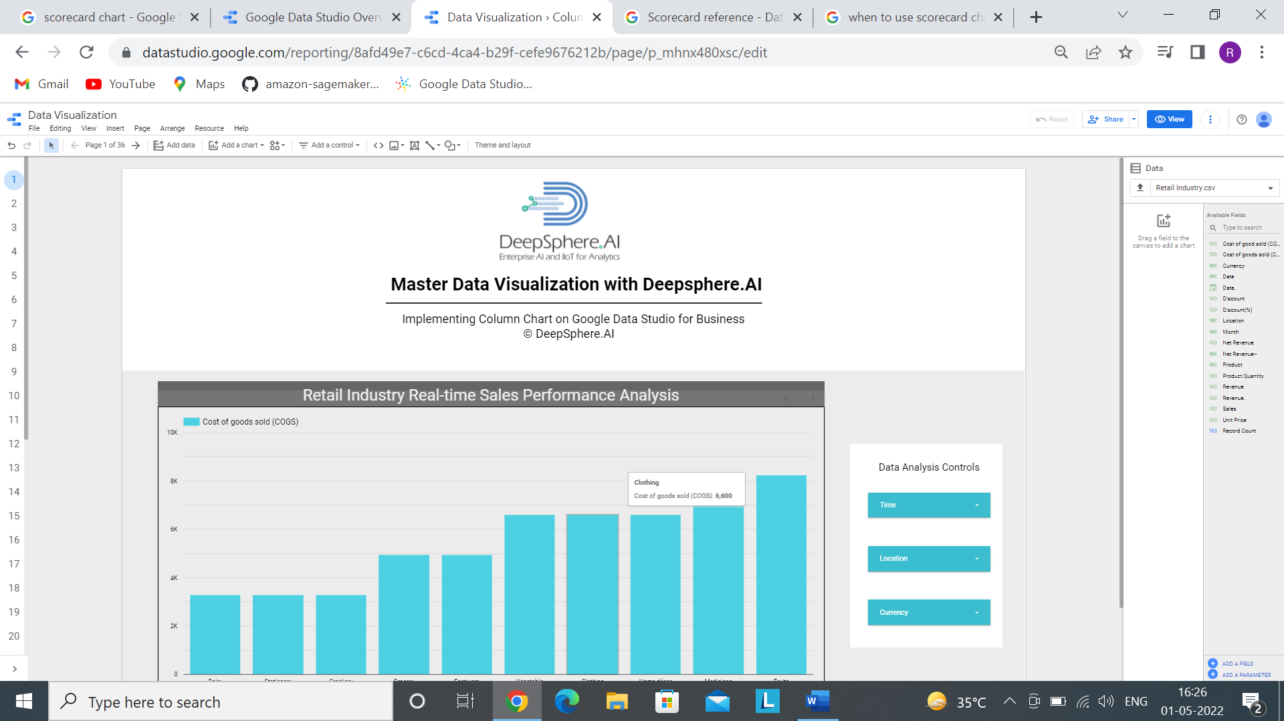

----> After adding a field, we will get this screen

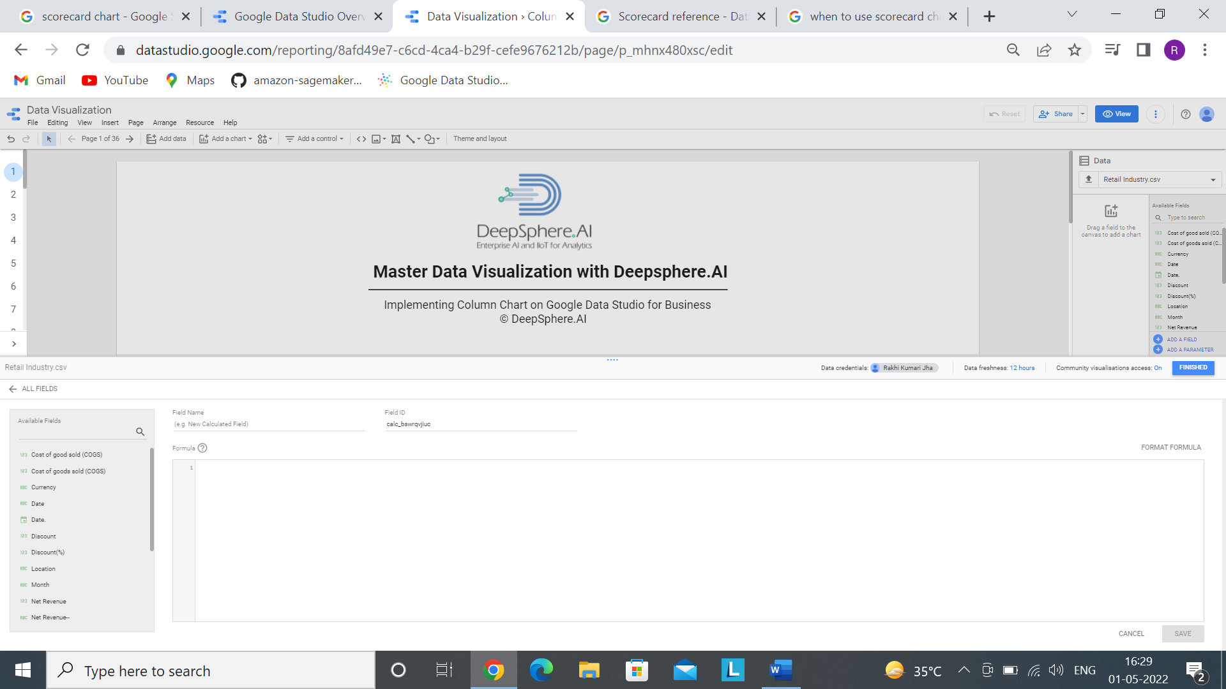

Here, We need to give a unique field name and give formula for that.

-----> Here we are creating several calculation field which will be used for different charts in the entire document.

**Product Quantity**

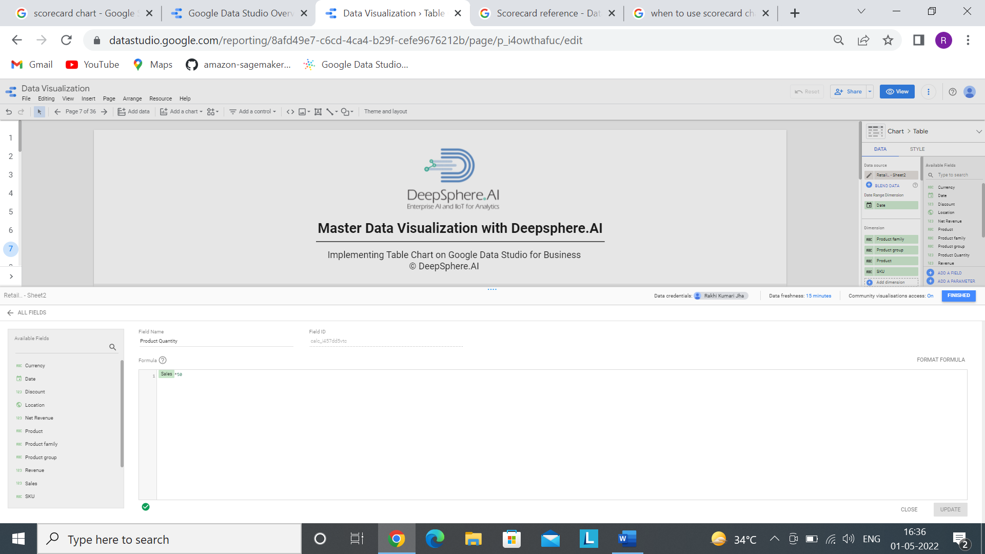

**Discount**

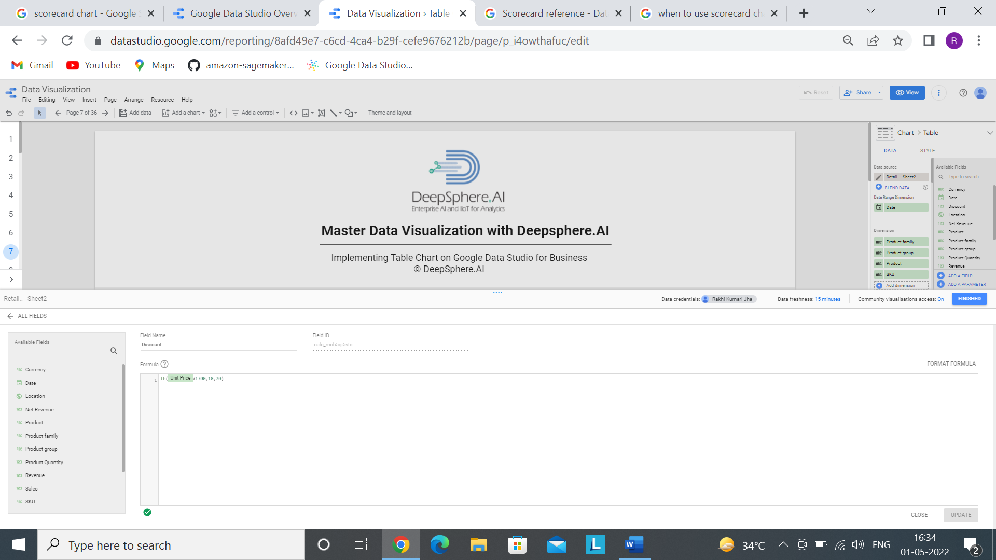

**Net Revenue**

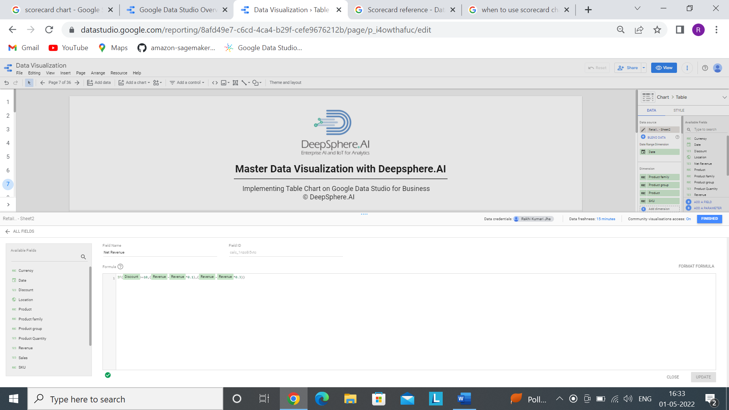

Step 4- Now after selecting a chart, we have to select proper dimension and metrics based on our requirement.

Here dimension is Product and the metric is Cost of goods sold

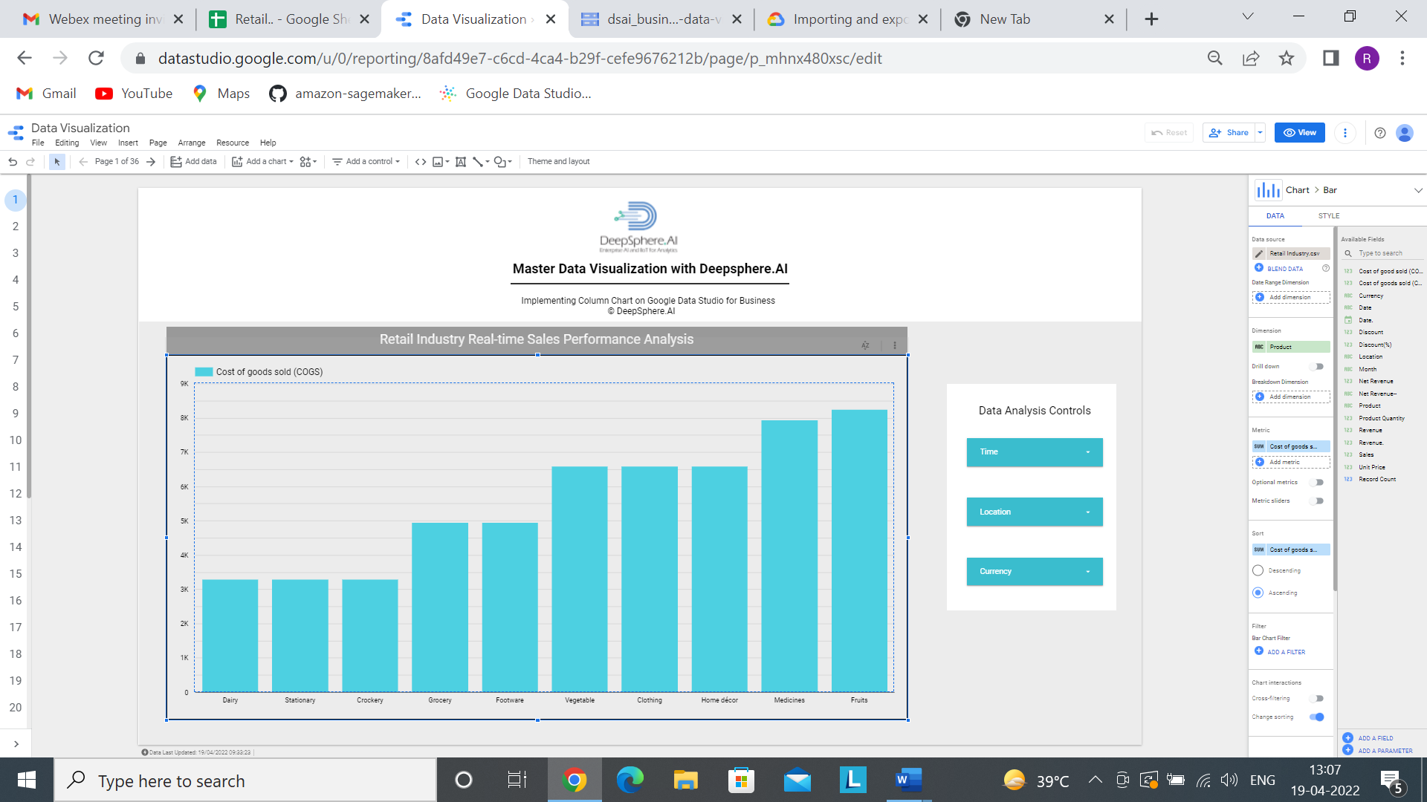

Step5- Based on the requirement, we can do the chart formatting.

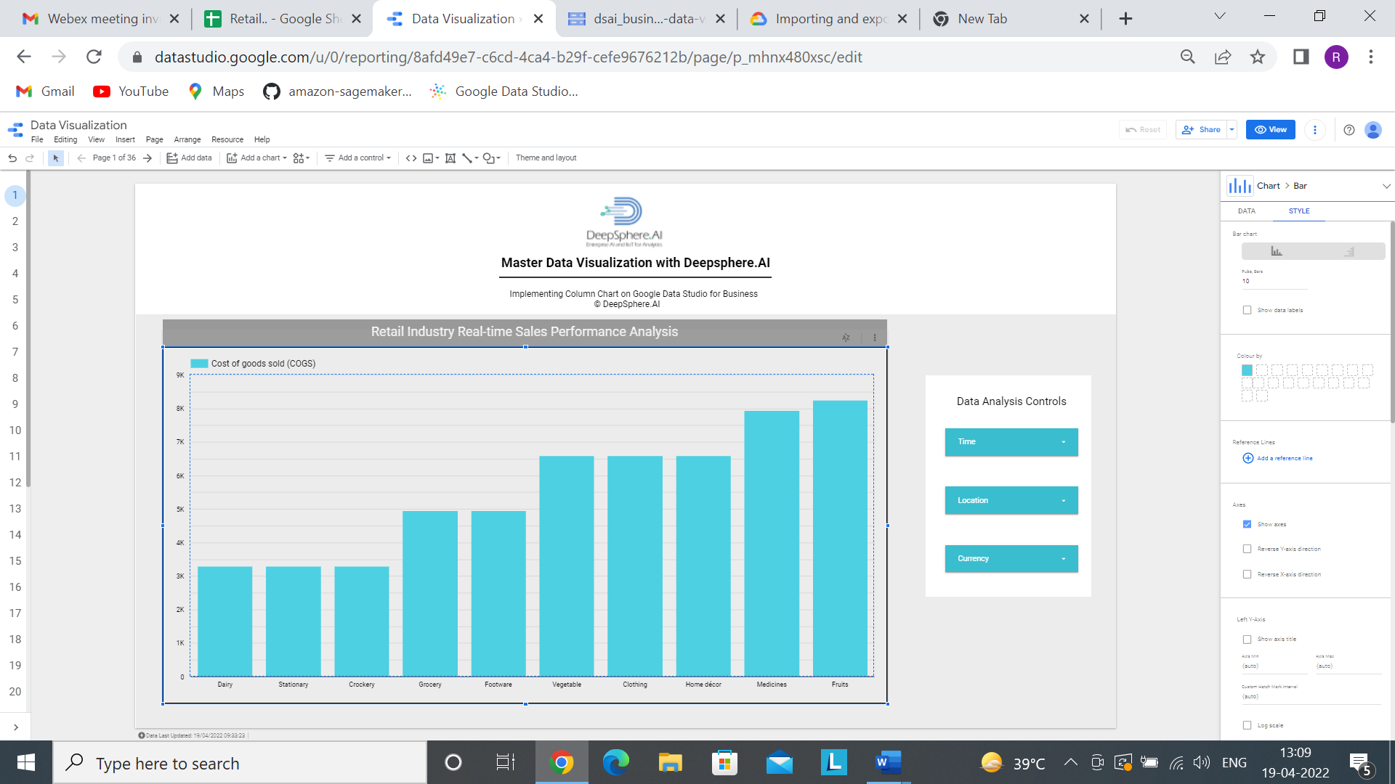

Step 6 Add the following filters

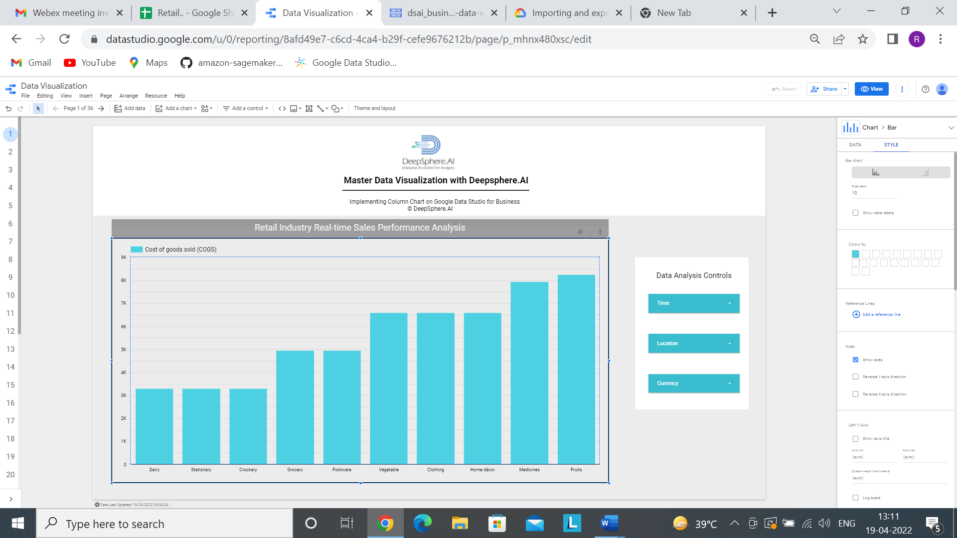

Add a control >>>>>>>>>> drop-down list

By following all the above steps, this is how the dashboard comes.

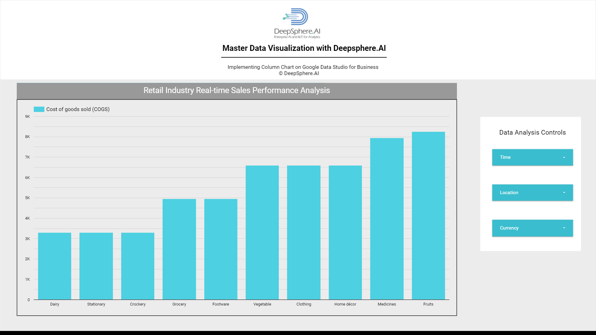

1.2 Stacked Column Chart

1.2.1- What is a Stacked Column chart?

Ans- Stacked Column Chart **incorporates several column series stacked vertically, one on another.** The value determines the length of each series in each data point.

1.2.2- When to use Stacked Column chart?

Ans- This Charts is a great option if you need to observe how several variables and their sum change simultaneously.

Example- Company xyz have sales data from Jan to Dec. They need to find the bestselling product of the year among all the branches of the company. Stacked Column chart can give the best comparative analysis for finding bestselling product with different factors like cost per product, Total cost and Sales of the product.

1.2.3- Does the Stacked Column chart needs dimensions and metrics?

Ans- Yes, Stacked Column chart needs both dimension and metrics where we can add only 1 dimension and 1 or more metrics. Along with metrics, we can add optional metrics as well based on our requirement. 1 dimension and 2 metric is mandatory and on the other side we can enable drill down option to analyze for different dimension.

1.2.4- In the Stacked Column chart, what is a dimension represents?

Ans- In Stacked Column chart, longer the bar means the greater the value it represents. So, one axis of the chart shows the specific categories being compared. The categories which are been used for comparison is known as dimension. Example- Product, Customer etc.

1.2.5- In the Stacked Column chart, what is a metrics(measures) represents?

Ans- In stacked column chart, one axis is dimension, and the other axis represents a discrete value of the dimension. And that discrete value is known as measures. Example- Cost of goods sold ,Revenue etc.

1.2.6- How does sample data look?

In 

1.2.7- How to develop a simple Stacked Column chart?

Ans-

Step1- Add data to Report.



Step-2 Click on Add to Report



Step 3- Click on Add a Chart and select Stacked Column chart.

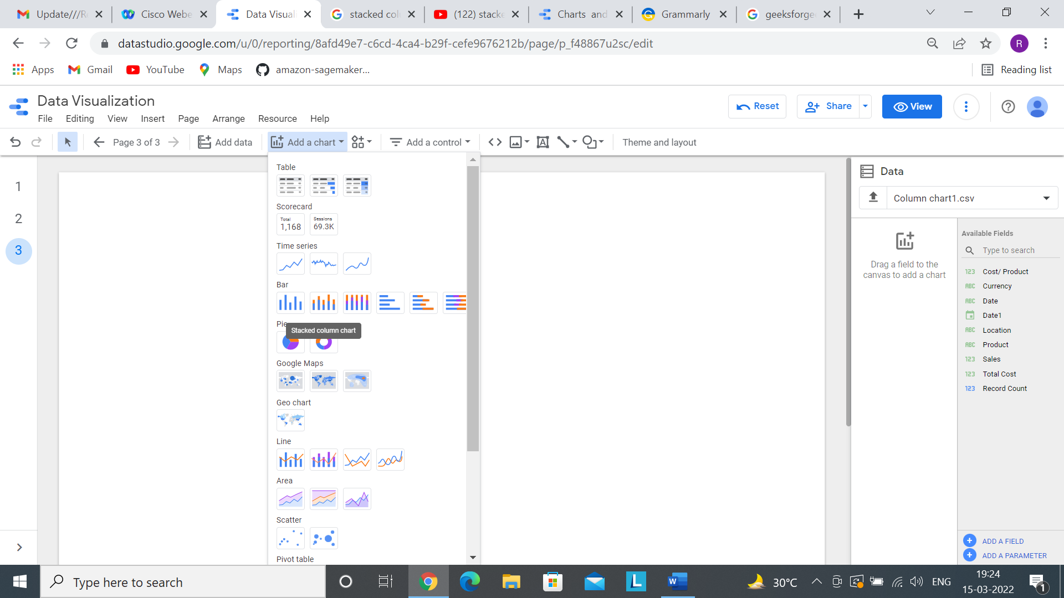

Step 4- Now after selecting a chart, we have to select proper dimension and metrics based on our requirement.

Here dimension is Product and the metric is Cost of goods sold, Unit Price and Quantity of Product.

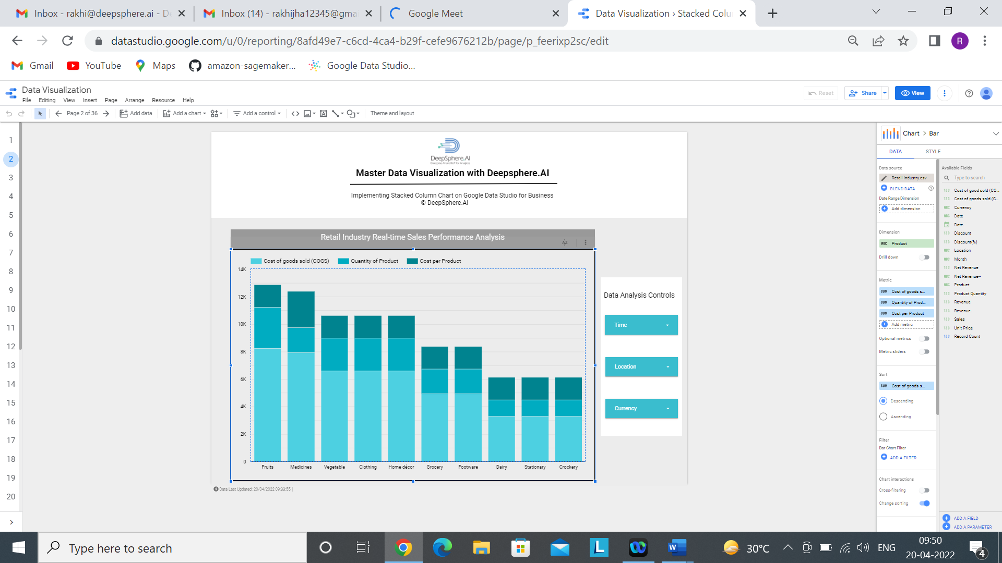

Step5- Based on the requirement, we can do the chart formatting.

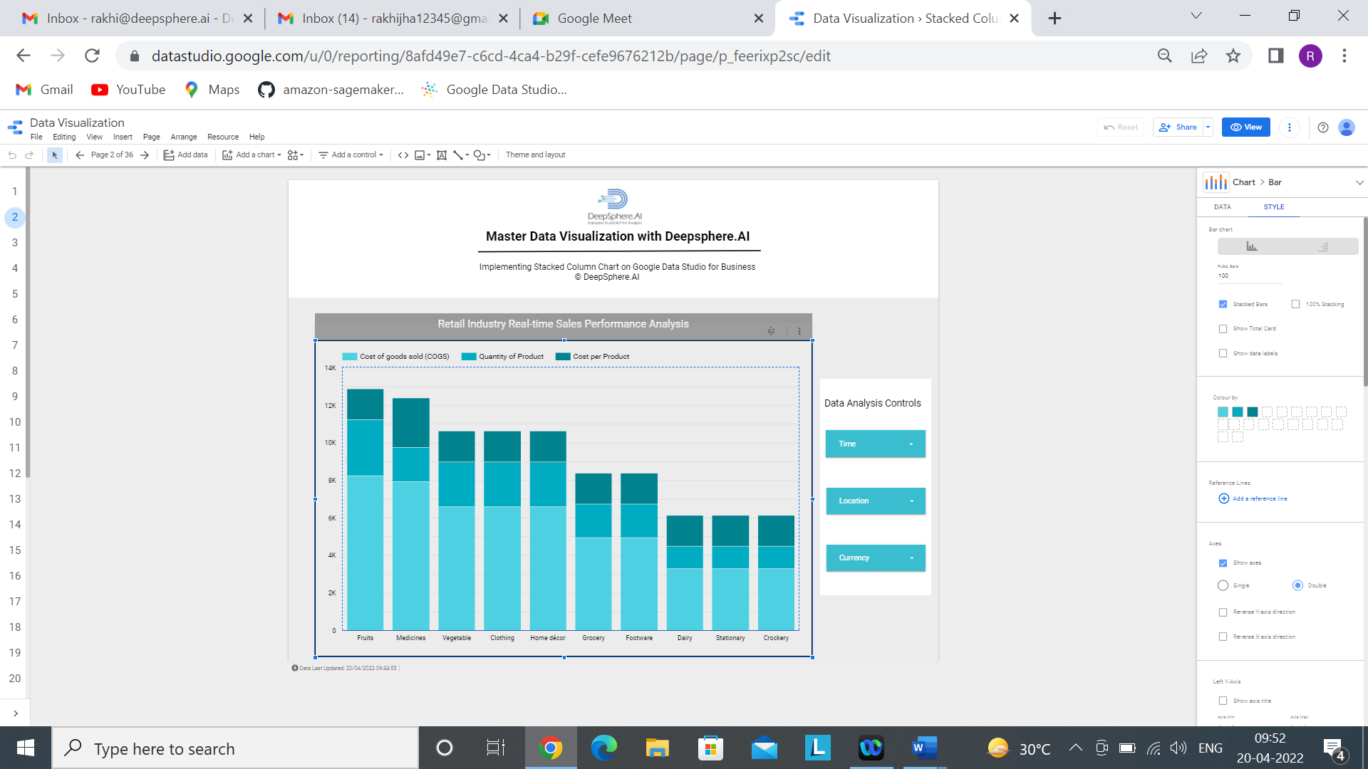

Step 5- Add the following filters

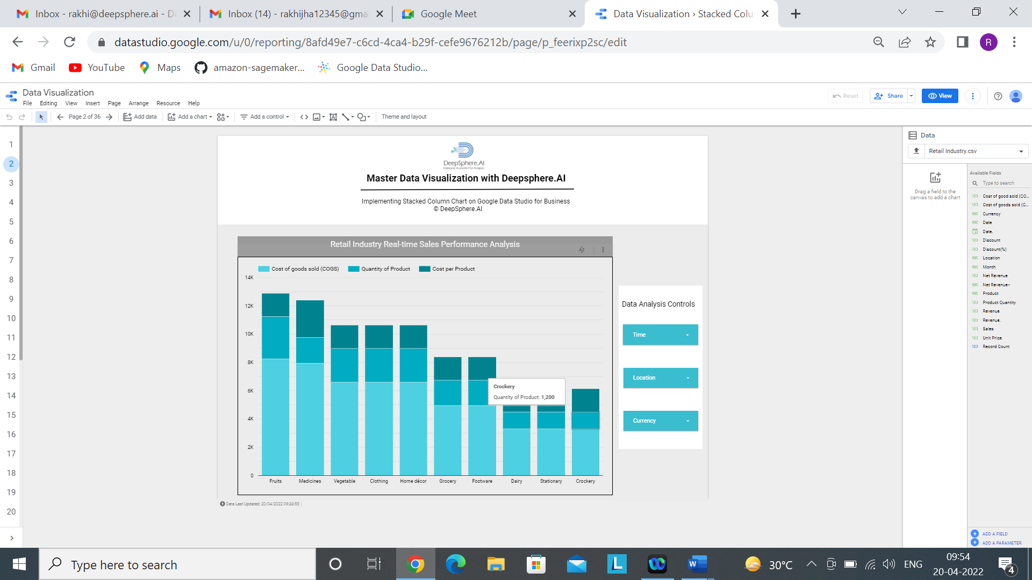

Add a control >>>>>>>>>> drop-down list

By following all the above steps, this is how the dashboard comes.

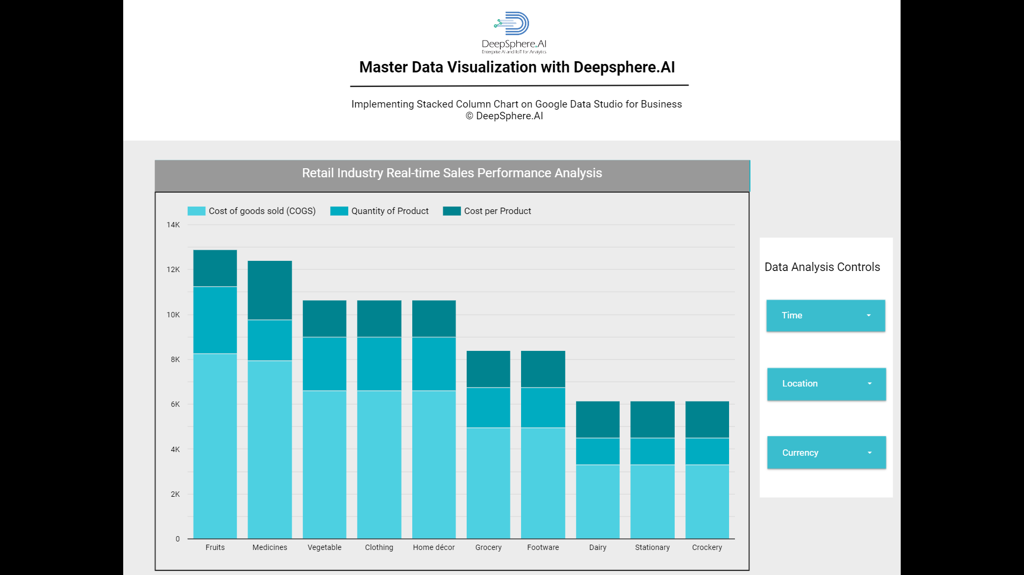

1.3 100% Stacked Column Chart

1.3.1 What is a 100% Stacked Column chart?

Ans- The 100% Stacked Column chart is **an extension of the Stacked Column chart. It compares based on a percentage of the total.**

1.3.2 When to use 100% Stacked Column chart?

Ans- This Charts is a great option if you need to observe how several variables and their sum change simultaneously.

Company xyz have sales data from Jan to Dec. They need to find the bestselling product of the year among all the branches of the company in percentage. 100% Stacked Column chart can give the best comparative analysis for finding bestselling product with different factors like Unit Price, Cost of goods sold and Sales of the product.

1.3.3 Does the 100% Stacked Column chart needs dimensions and metrics?

Ans- Yes, 100% Stacked Column chart needs both dimension and metrics where we can add only 1 dimension and 1 or more metrics. Along with metrics, we can add optional metrics as well based on our requirement. 1 dimension and 2 metric is mandatory, we can add more than 2 and on the other side we can enable drill down option to analyze for different dimension.

1.3.4 In the 100% Stacked Column chart, what is a dimension represents?

Ans- In 100% Stacked Column chart, higher the percentage means the greater the value it represents. So, one axis of the chart shows the specific categories being compared. The categories which are been used for comparison is known as dimension. Example- Product, Customer etc.

1.3.5 In the 100% Stacked Column chart, what is a metrics represents?

Ans- In 100% stacked column chart, one axis is dimension, and the other axis represents a discrete value of the dimension. And that discrete value is known as measures. Example- Total cost, sales etc.

1.3.6 How does sample data look?

In 

1.3.7 How to develop a simple Stacked Column chart?

Ans-

Step1- Add data to Report.

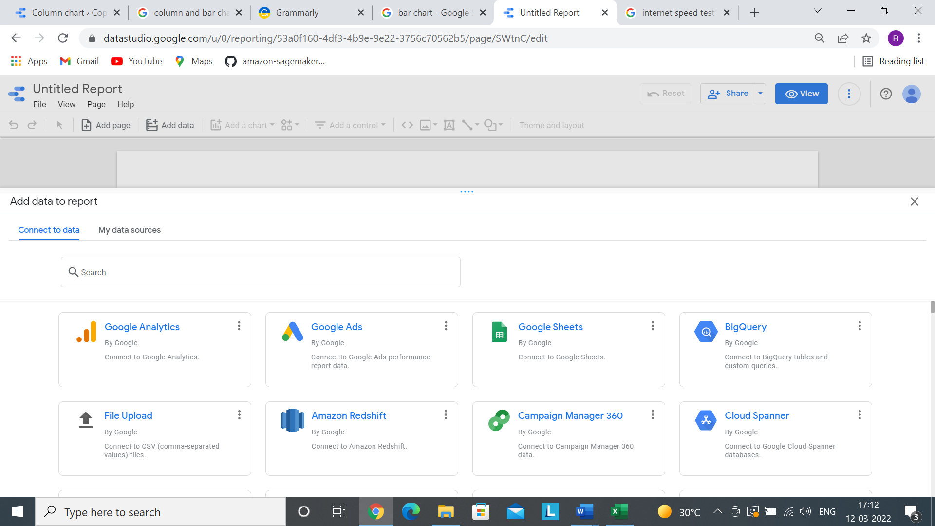

Step-2 Click on Add to Report



Step 3- Click on Add a Chart and select 100% Stacked Column chart.

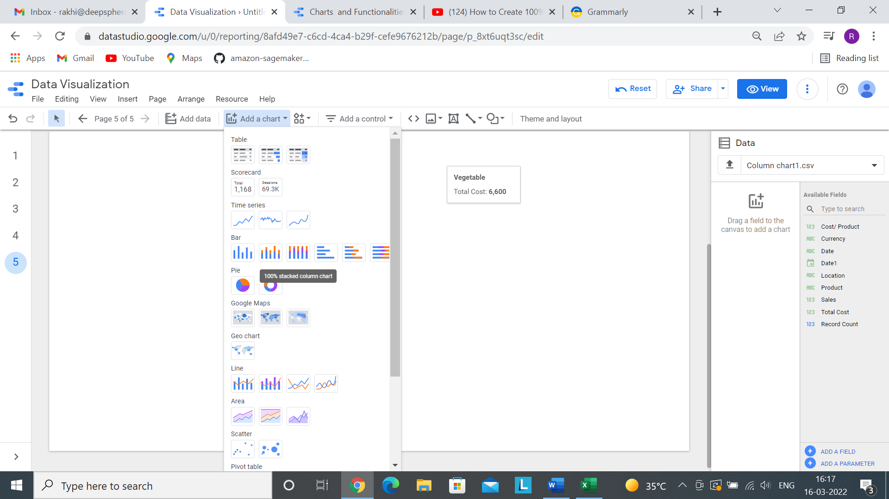

Step 4- Now after selecting a chart, we have to select proper dimension and metrics based on our requirement.

Here dimension is Product and the metric is Total cost, cost per Product and Sales.

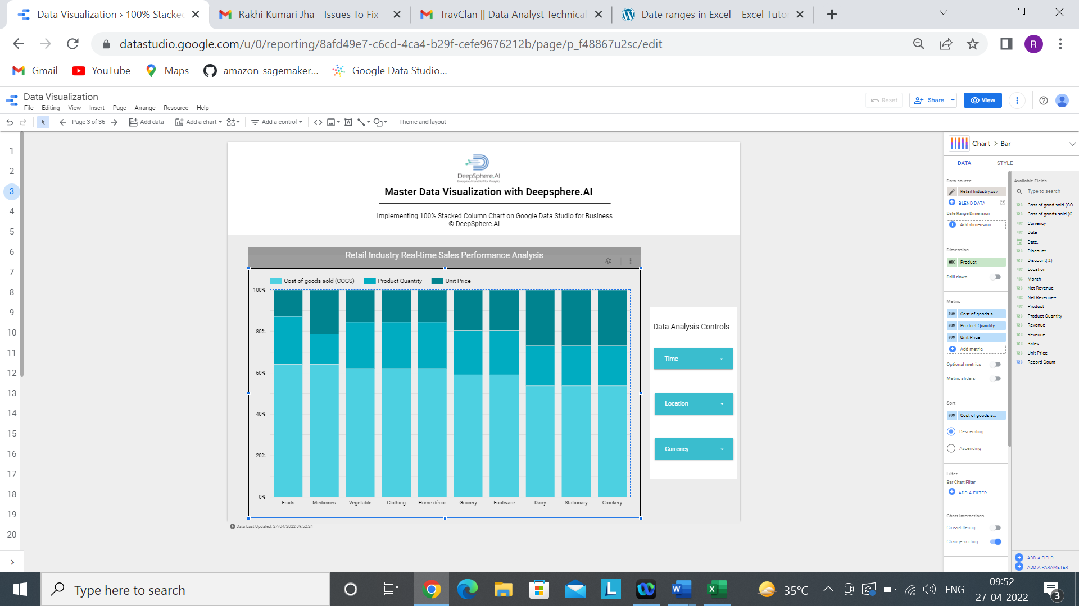

Step5- Based on the requirement, we can do the chart formatting.

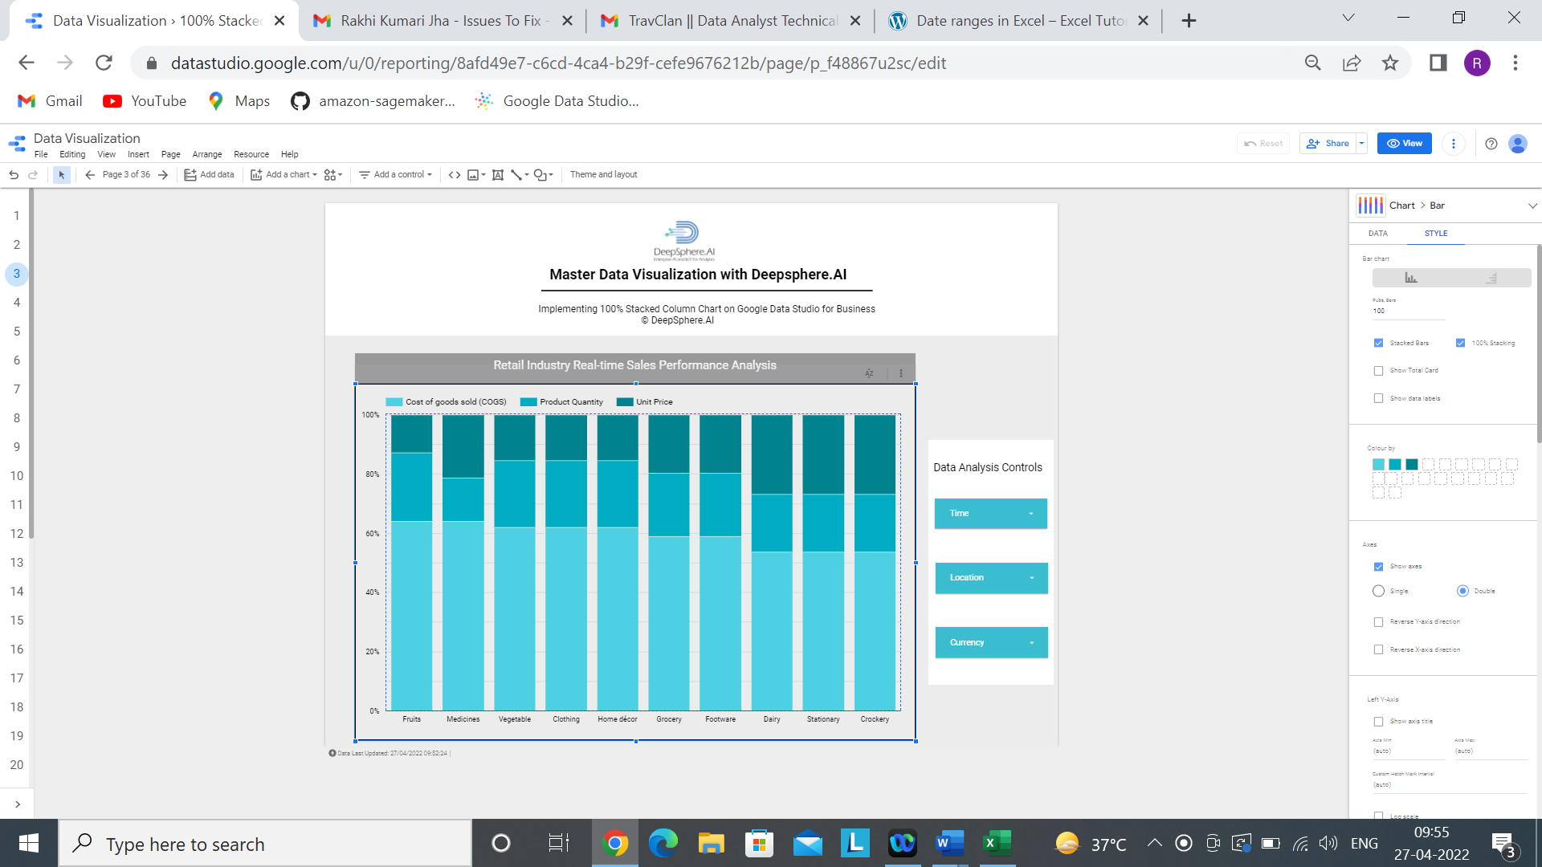

Step 5 Add the following filters



Add a control >>>>>>>>>> drop-down list

By following all the above steps, this is how the dashboard comes.



1.4 Bar Chart

1.4.1- What is a bar chart?

Ans- A bar chart is a data visualization chart in which each category is represented by a rectangular block horizontally, where the height of the rectangle gives the required value.

1.4.2- When to use bar chart?

Ans- This Charts is a great option if you need to observe how several variables and their sum change simultaneously.

Example- Company xyz have sales data from Jan to Dec. They need to find the bestselling product of the year among all the branches of the company. Bar chart can give the best comparative analysis for finding bestselling product with different factors like cost per product, Total cost and Sales of the product.

1.4.3- Does the bar chart needs dimensions and metrics?

Ans- Yes, bar chart needs both dimension and metrics where we can add only 1 dimension and 1 or more metrics. Along with metrics, we can add optional metrics as well based on our requirement. 1 dimension and 2 metric is mandatory, we can add more than 2 and on the other side we can enable drill down option to analyze for different dimension.

1.4.4- In the bar chart, what is a dimension represents?

Ans- In bar chart, higher the percentage means the greater the value it represents. So, one axis of the chart shows the specific categories being compared. The categories which are been used for comparison is known as dimension. Example- Product, Customer etc.

1.4.5- In the bar chart, what is a metrics represents?

Ans- In bar chart, one axis is dimension, and the other axis represents a discrete value of the dimension. And that discrete value is known as measures. Example- Total cost, sales etc.

1.4.6- How does sample data look?

In 

1.4.7- How to develop a simple bar chart?

Ans-

Step1- Add data to Report.



Step-2 Click on Add to Report



Step 3- Click on Add a Chart and select bar chart.

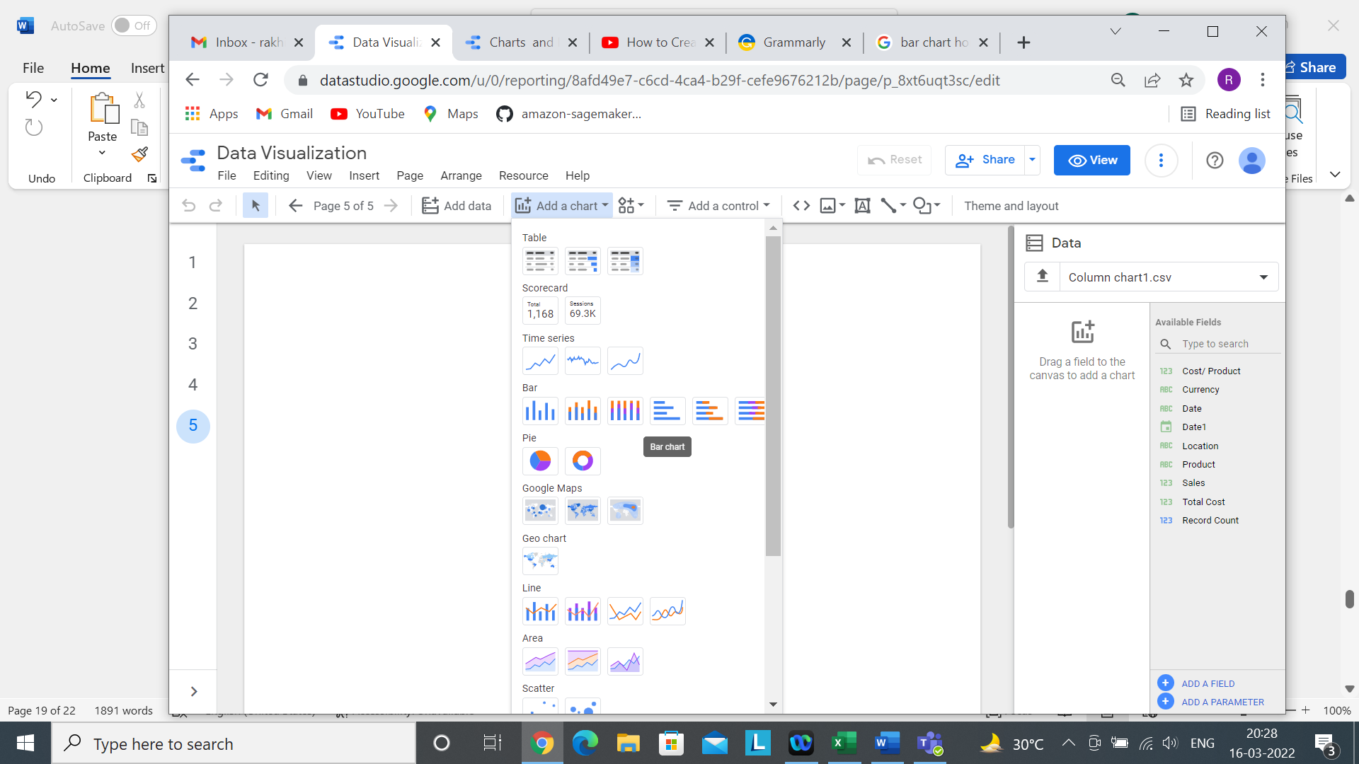

Step 4- Now after selecting a chart, we have to select proper dimension and metrics based on our requirement.

Here dimension is Product and the metric is Cost of goods sold.

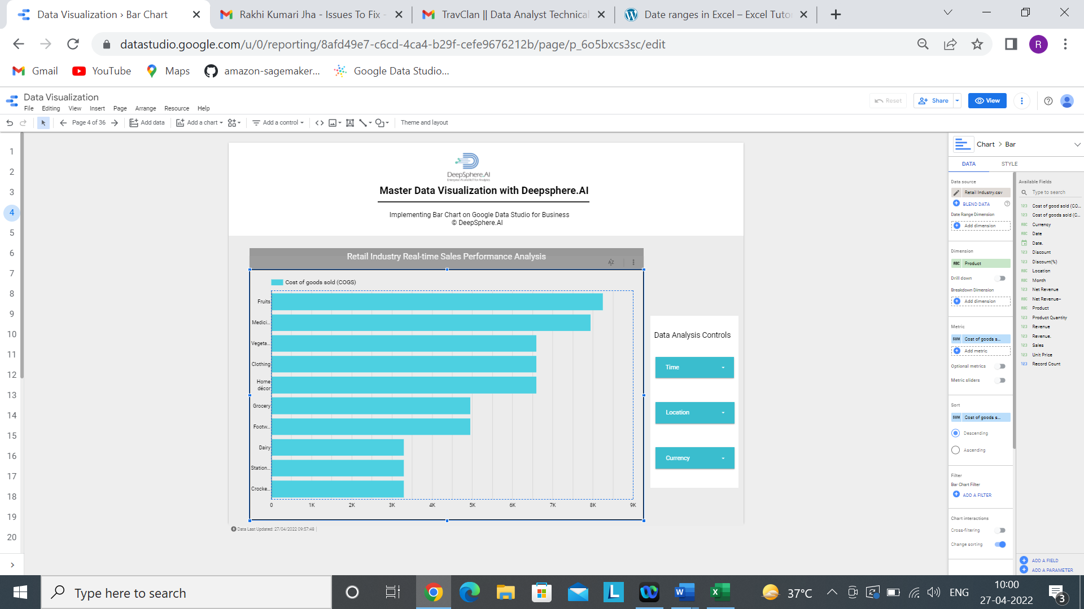

Step5- Based on the requirement, we can do the chart formatting.

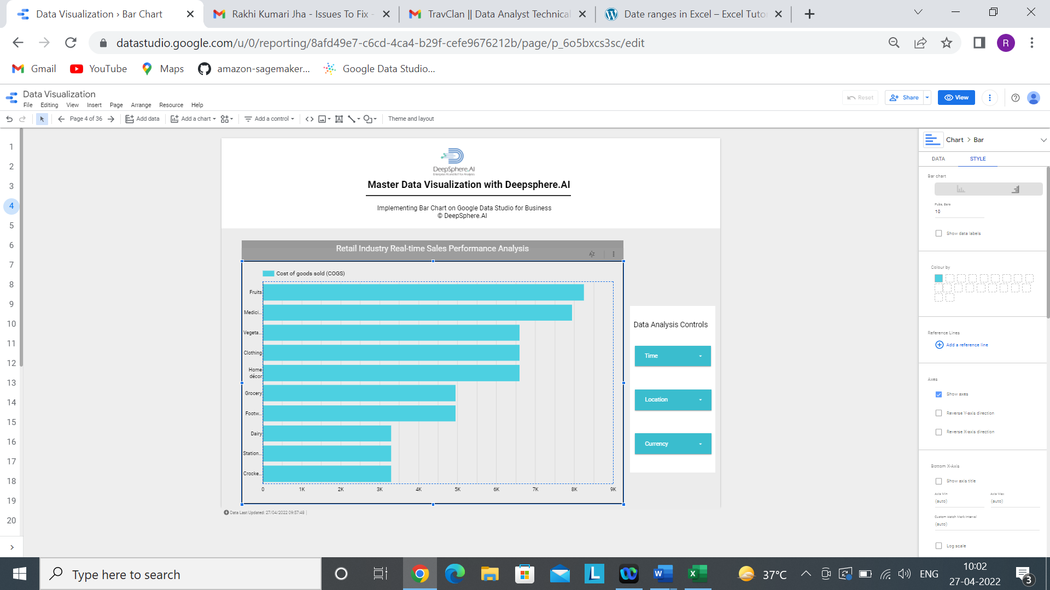

Step 5 Add the following filters

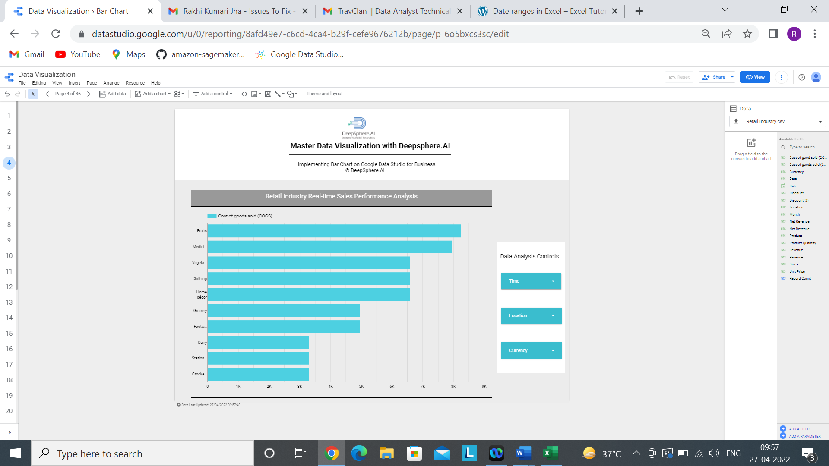

Add a control >>>>>>>>>> drop-down list

By following all the above steps, this is how the dashboard comes.



1.5Stacked bar Chart

1.5.1 - What is a Stacked bar chart?

Ans- Stacked bar Chart**incorporates several column series stacked horizontally, one on another.** The value determines the length of each series in each data point.

1.5.2- When to use Stacked bar chart?

Ans- This Charts is a great option if you need to observe how several variables and their sum change simultaneously.

Example- Company xyz have sales data from Jan to Dec. They need to find the bestselling product of the year among all the branches of the company. Stacked bar chart can give the best comparative analysis for finding bestselling product with different factors like cost per product, Total cost and Sales of the product.

1.5.3- Does the Stacked bar chart needs dimensions and metrics?

Ans- Yes, Stacked bar chart needs both dimension and metrics where we can add only 1 dimension and 1 or more metrics. Along with metrics, we can add optional metrics as well based on our requirement. 1 dimension and 2 metric is mandatory and on the other side we can enable drill down option to analyze for different dimension.

1.5.4- In the Stacked bar chart, what is a dimension represents?

Ans- In Stacked bar chart, longer the bar means the greater the value it represents. So, one axis of the chart shows the specific categories being compared. The categories which are been used for comparison is known as dimension. Example- Product, Customer etc.

1.5.5- In the Stacked bar chart, what is a metrics represents?

Ans- In stacked bar chart, one axis is dimension, and the other axis represents a discrete value of the dimension. And that discrete value is known as measures. Example- Cost of goods sold etc.

1.5.6- How does sample data look?

In 

1.5.7- How to develop a simple Stacked Column chart?

Ans-

Step1- Add data to Report.



Step-2 Click on Add to Report

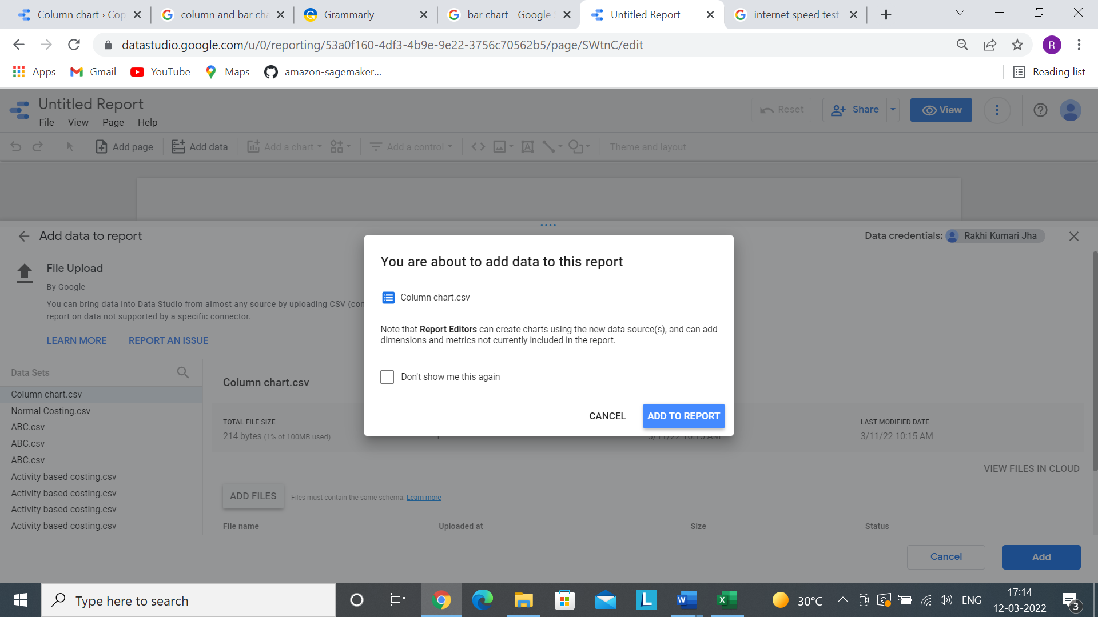

Step 3- Click on Add a Chart and select Stacked bar chart.

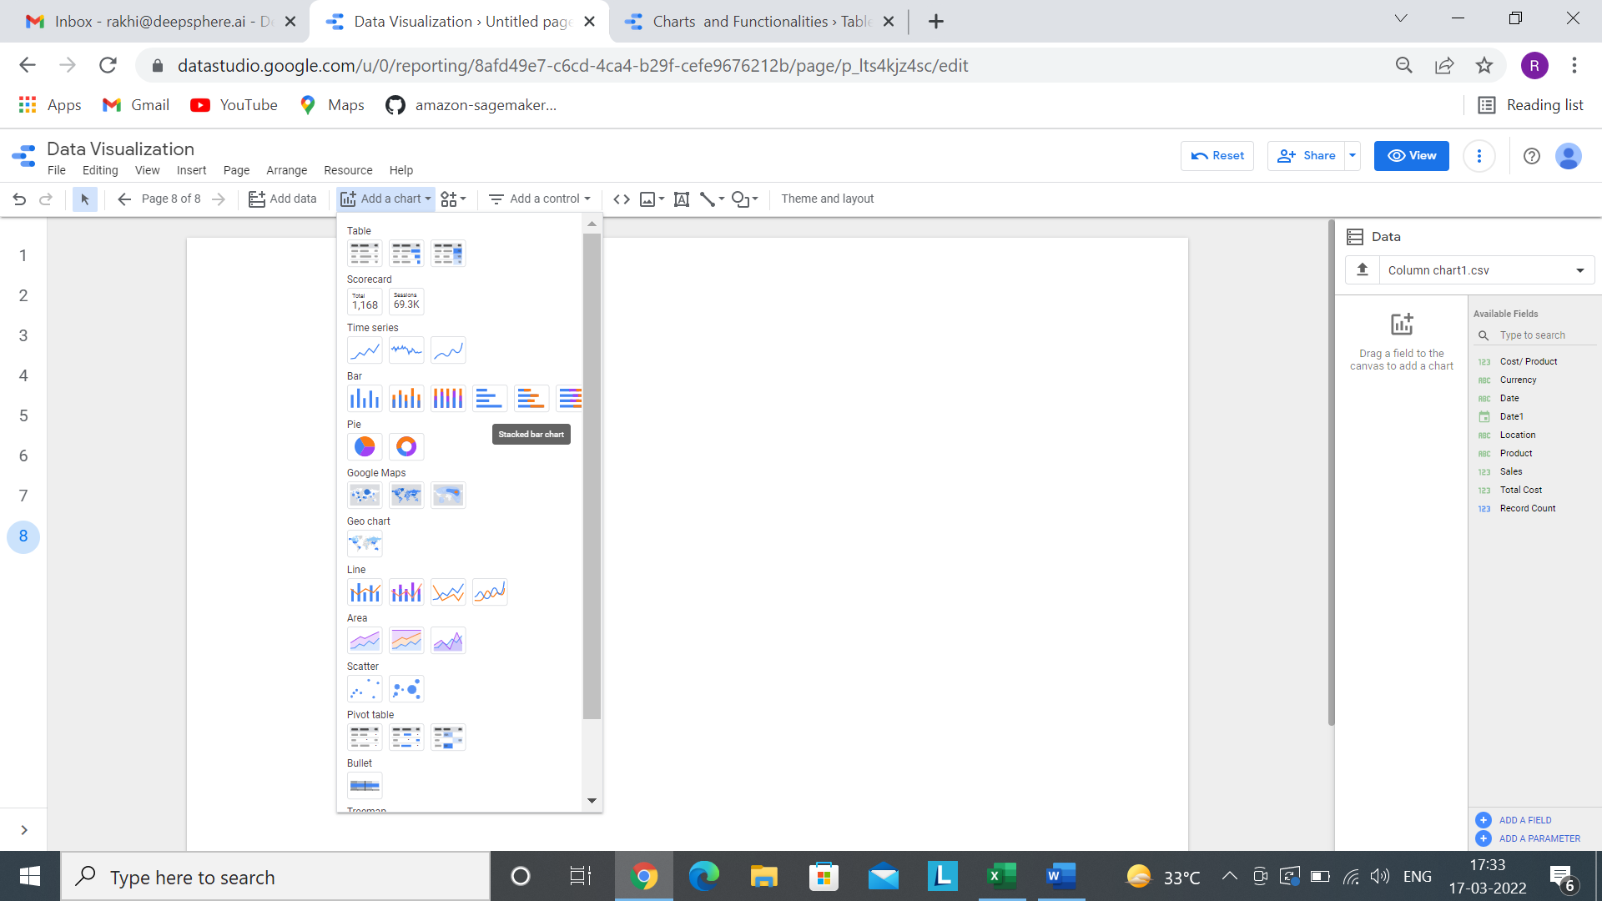

Step 4- Now after selecting a chart, we have to select proper dimension and metrics based on our requirement.

Here dimension is Product and the metric is Cost of goods sold, Product Quantity and Unit Price.

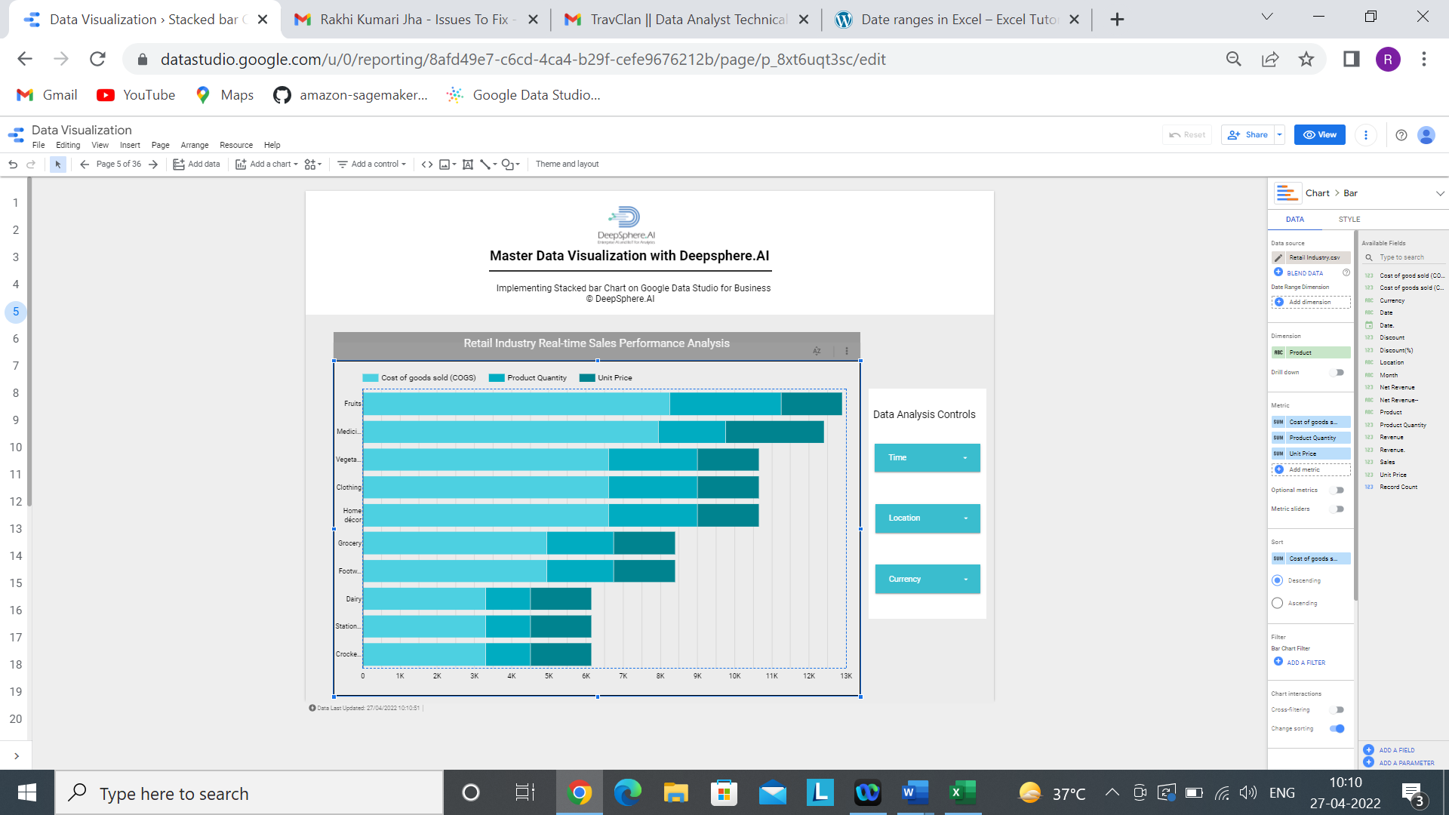

Step5- Based on the requirement, we can do the chart formatting.

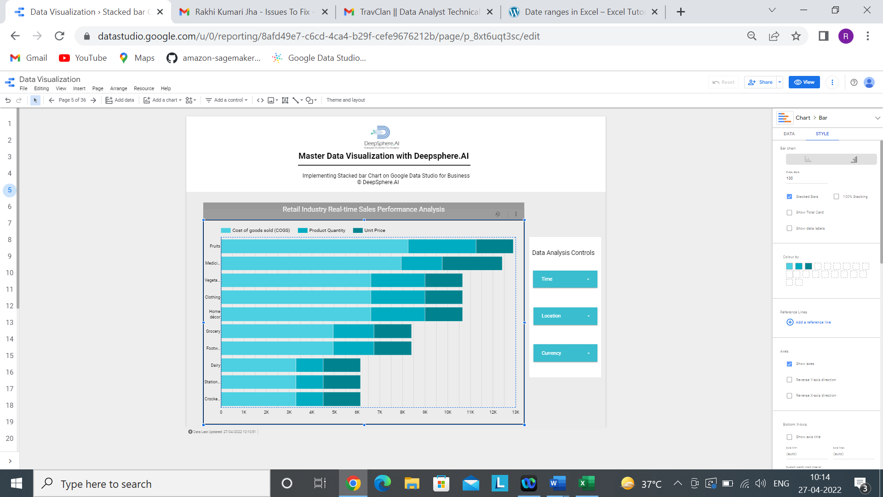

Step 5 Add the following filters



Add a control >>>>>>>>>> drop-down list

By following all the above steps, this is how the dashboard comes.



1.6 100% Stacked bar Chart

1.6.1- What is a 100% Stacked bar chart?

Ans- The 100% Stacked Column chart is**an extension of the Stacked bar chart. It compares based on a percentage of the total.**

1.6.2- When to use 100% Stacked bar chart?

Ans- This Charts is a great option if you need to observe how several variables and their sum change simultaneously.

Example-Company xyz have sales data from Jan to Dec. They need to find the bestselling product of the year among all the branches of the company in percentage. 100% Stacked bar chart can give the best comparative analysis for finding bestselling product with different factors like cost per product, Total cost and Sales of the product.

1.6.3- Does the 100% Stacked bar chart needs dimensions and metrics?

Ans- Yes, 100% Stacked bar chart needs both dimension and metrics where we can add only 1 dimension and 1 or more metrics. Along with metrics, we can add optional metrics as well based on our requirement. 1 dimension and 2 metric is mandatory, we can add more than 2 and on the other side we can enable drill down option to analyze for different dimension.

1.6.4- In the 100% Stacked bar chart, what is a dimension represents?

Ans- In 100% Stacked bar chart, higher the percentage means the greater the value it represents. So, one axis of the chart shows the specific categories being compared. The categories which are been used for comparison is known as dimension. Example- Product, Customer etc.

1.6.5- In the 100% Stacked bar chart, what is a metrics represents?

Ans- In 100% stacked bar chart, one axis is dimension, and the other axis represents a discrete value of the dimension. And that discrete value is known as measures. Example- Cost of goods sold, sales etc.

1.6.6- How does sample data look?



1.6.7- How to develop a simple Stacked bar chart?

Ans-

Step1- Add data to Report.



Step-2 Click on Add to Report



Step 3- Click on Add a Chart and select 100% Stacked bar chart.

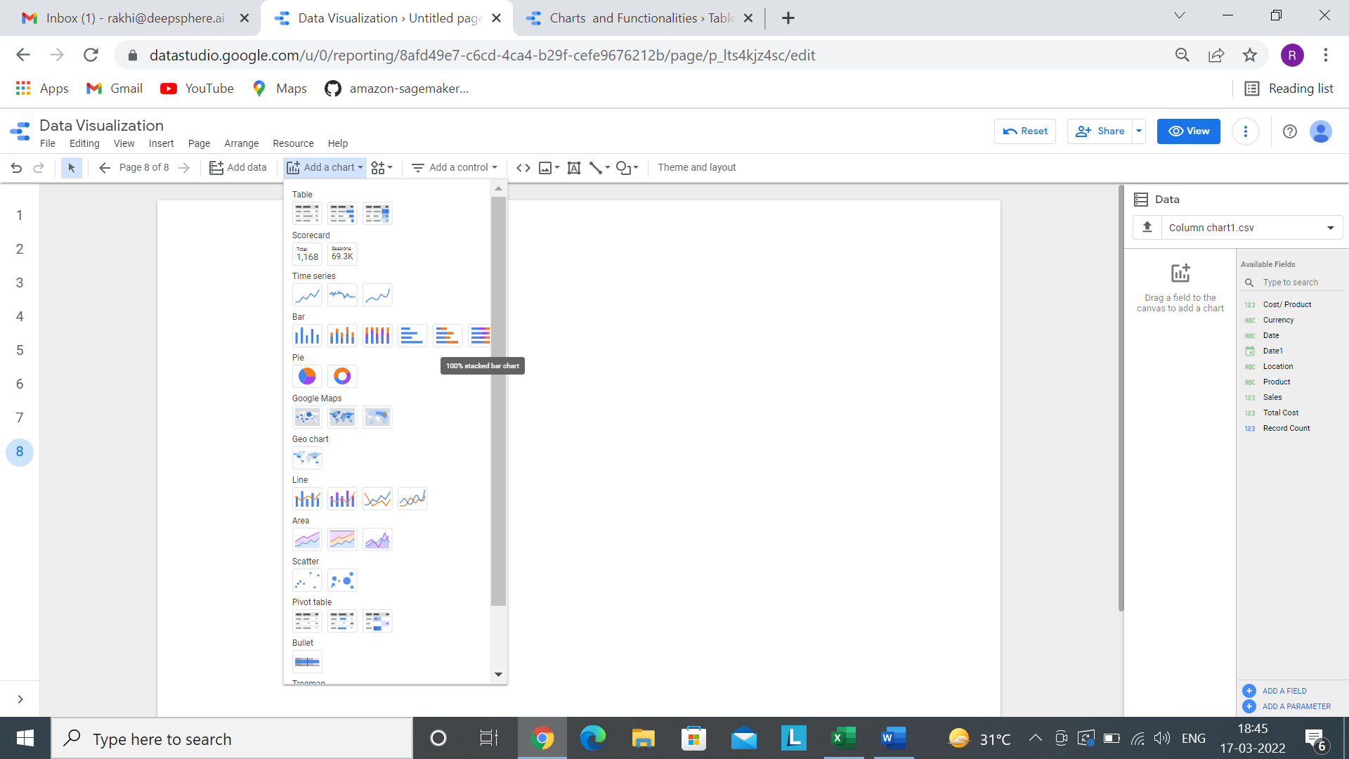

Step 4- Now after selecting a chart, we have to select proper dimension and metrics based on our requirement.

Here dimension is Product and the metric is Cost of goods sold, Product Quantity and Unit Price.

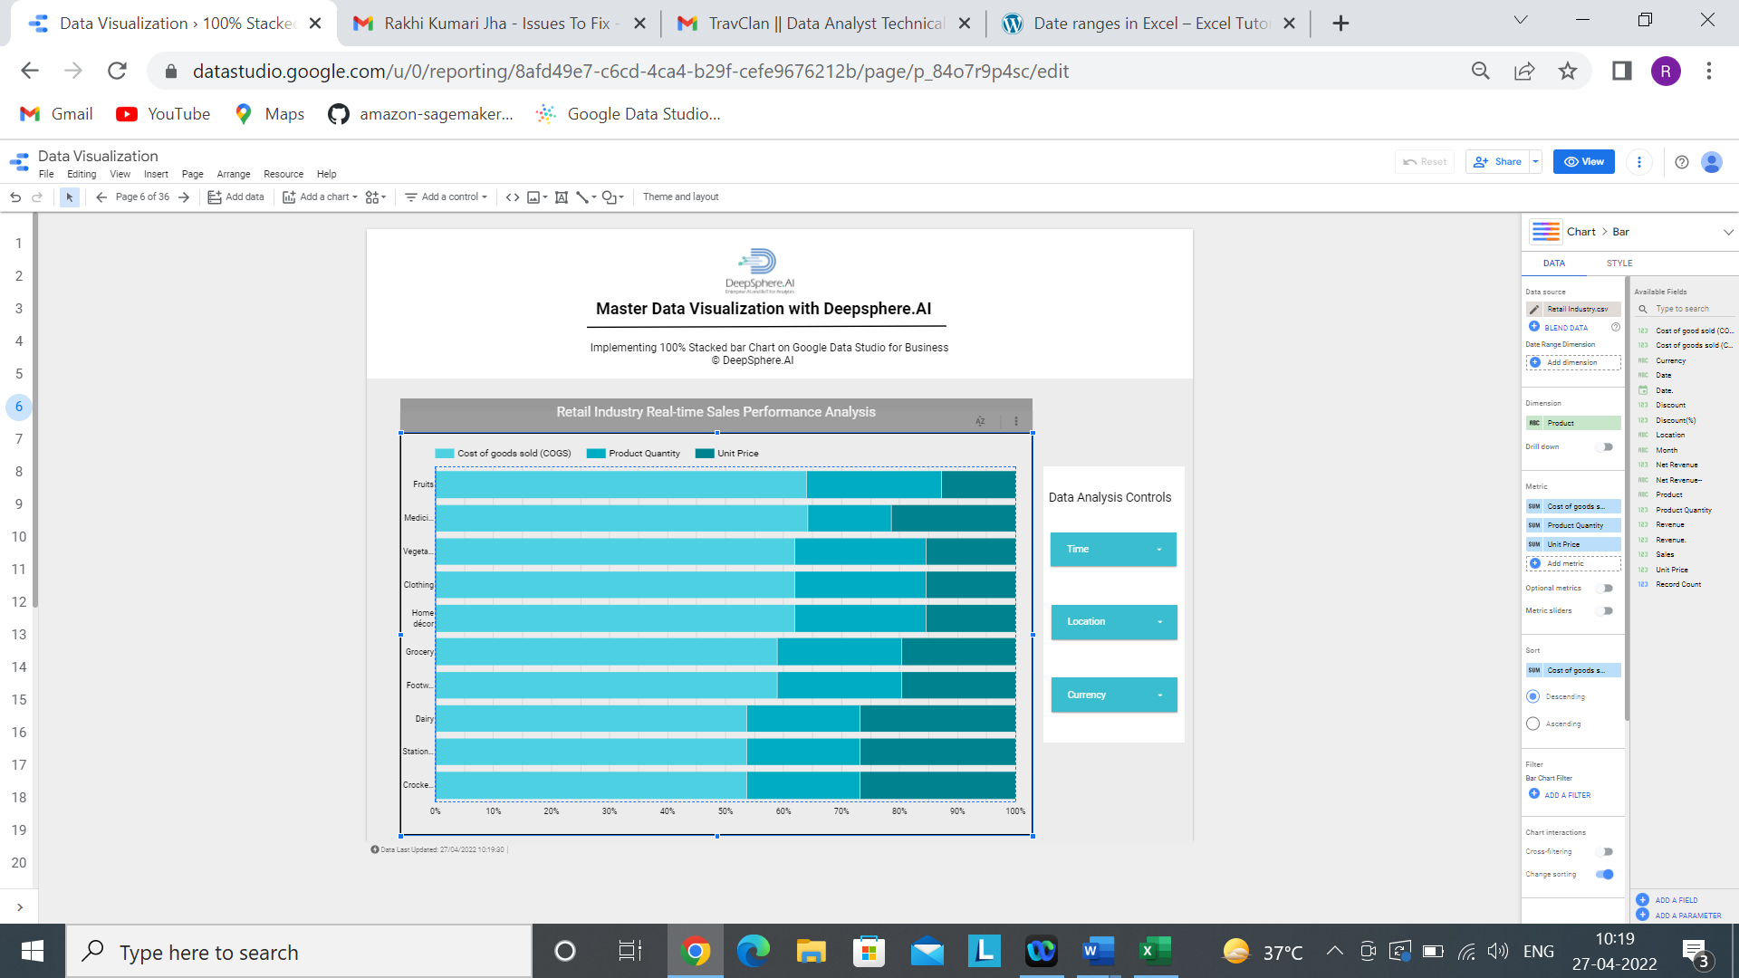

Step5- Based on the requirement, we can do the chart formatting.

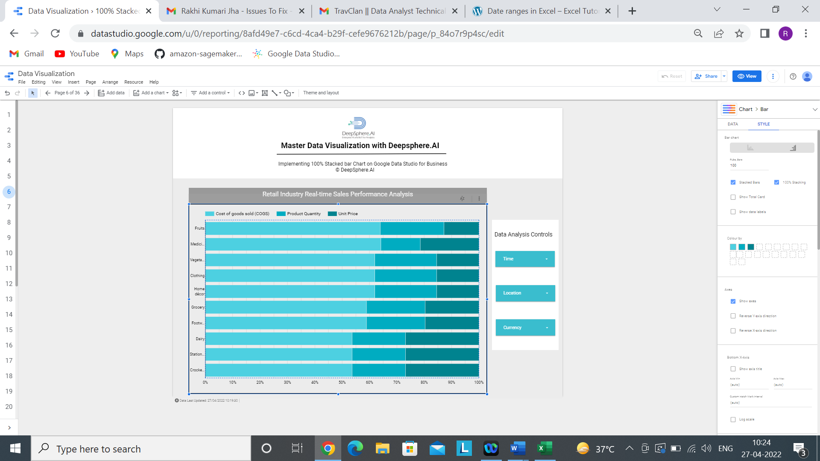

Step 5 Add the following filters



Add a control >>>>>>>>>> drop-down list

1.6.8- Develop a 100% Stacked bar chart with appropriate title and color, logo, etc.

Ans- By following all the above steps, this is how the dashboard comes.



1. **Table**

2.1 Table Chart

2.1.1- What is a Table?

Ans- Tables display your data in a grid of rows and columns. Each column represents a dimension or metric, while each row is one record of your data.

2.1.2- When to use Table?

Ans- **Tables is important if precise number is important.**

* If a company wants exact numeral data for analysis, then table is a great option.
* If a retail company wants exact amount of sales, Total expenditure etc. in a grid then table is used.

2.1.3- Does the Table needs dimensions and metrics?

Ans- Yes, Table needs both dimension and metrics, where we can add multiple dimensions and metrics based on our requirement. In this chart drill down option is enabled.

2.1.4- In the Table, what is a dimension represents?

Ans- Dimensions are data categories. Dimension values (the data contained by the dimension) are names, descriptions or other characteristics of a category.

Add dimensions to the chart by dragging fields from the Available Fields panel on the right. You can also click Add dimension in the Data tab.

2.1.5- In the Table, what is a metrics represents?

Ans- Metrics measure the things contained in dimensions and provide the numeric scale and data series for the chart.

Add metrics to the chart by dragging fields from the Available Fields panel on the right. You can also click **Add metric** in the Data tab.

Metrics are aggregations that come from the underlying data set, or are the result of implicitly or explicitly applying an aggregation function, such as COUNT(), SUM(), or AVG(). The metric itself has no defined set of values, so you can’t group by it, as you can with a dimension.

2.1.6- How does sample data look?

Ans-



2.1.7- How to develop a Table?

Ans- Step1- Add data to Report.



Step-2 Click on Add to Report



Step 3- Click on Add a Chart and select Table.

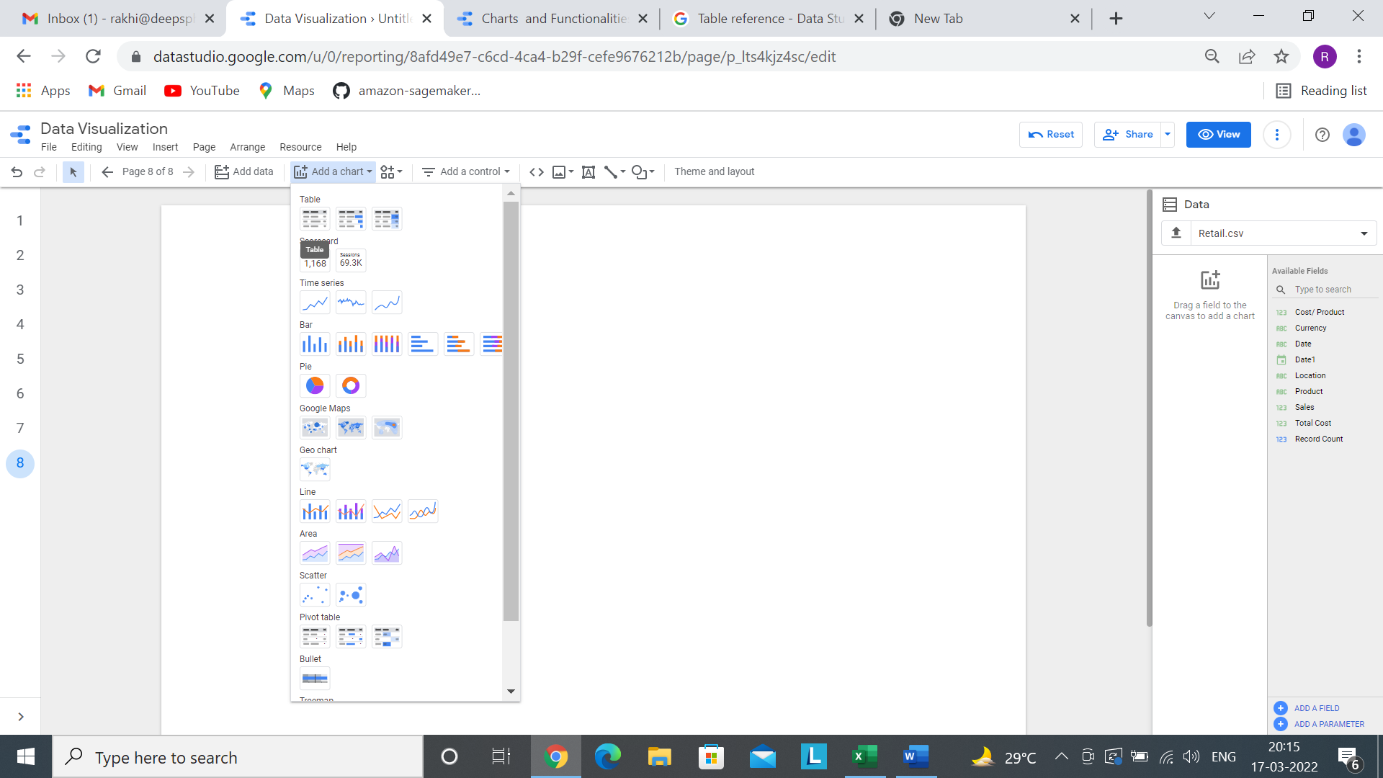

Step 4- Now after selecting a chart, we have to select proper dimension and metrics based on our requirement.

Here dimension is Product family, Product group Product & SKU and the metric is Unit Price, Product Quantity, Revenue, Cost of goods sold and Net Revenue.

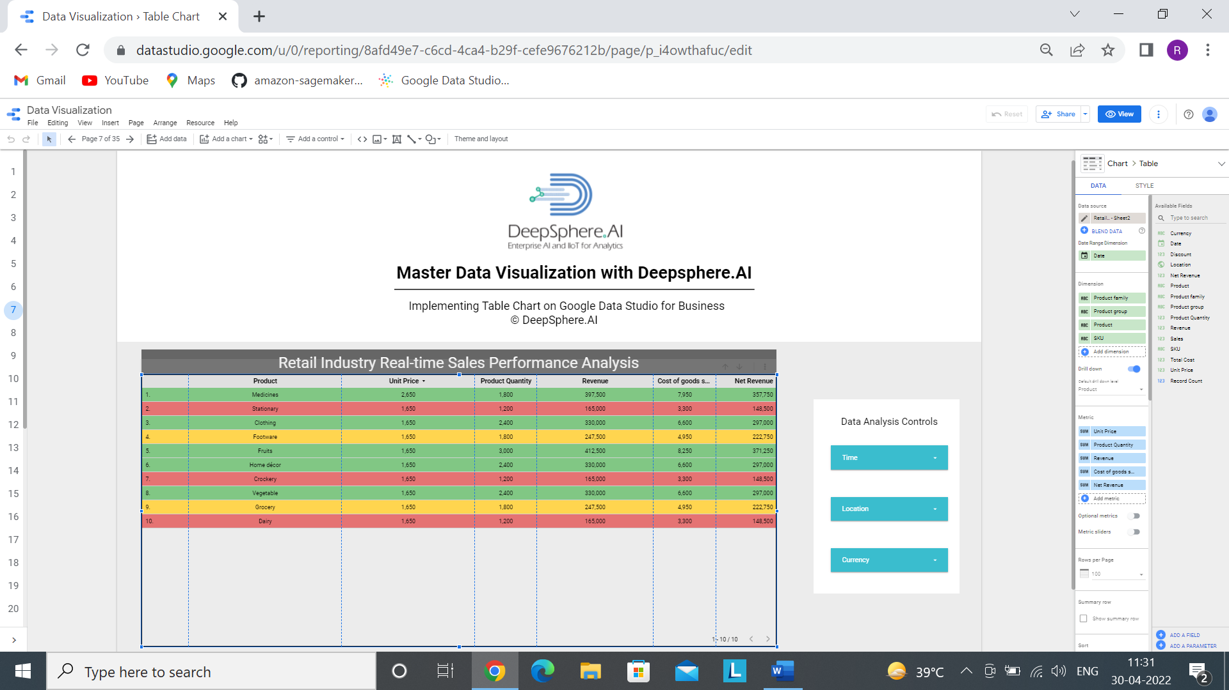

Step5- Based on the requirement, we can do the chart formatting.

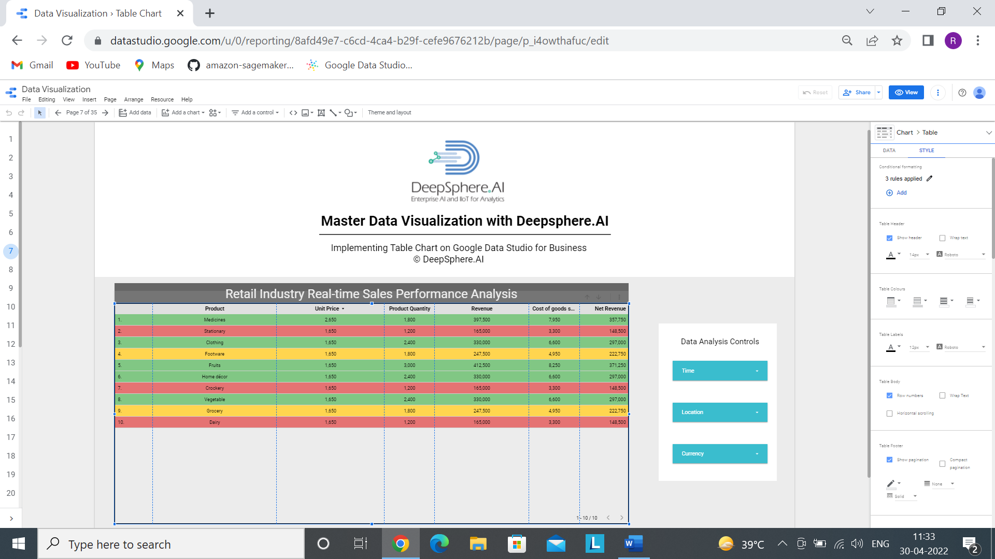

Adding Conditional formatting, Inside it we will give condition for each color.

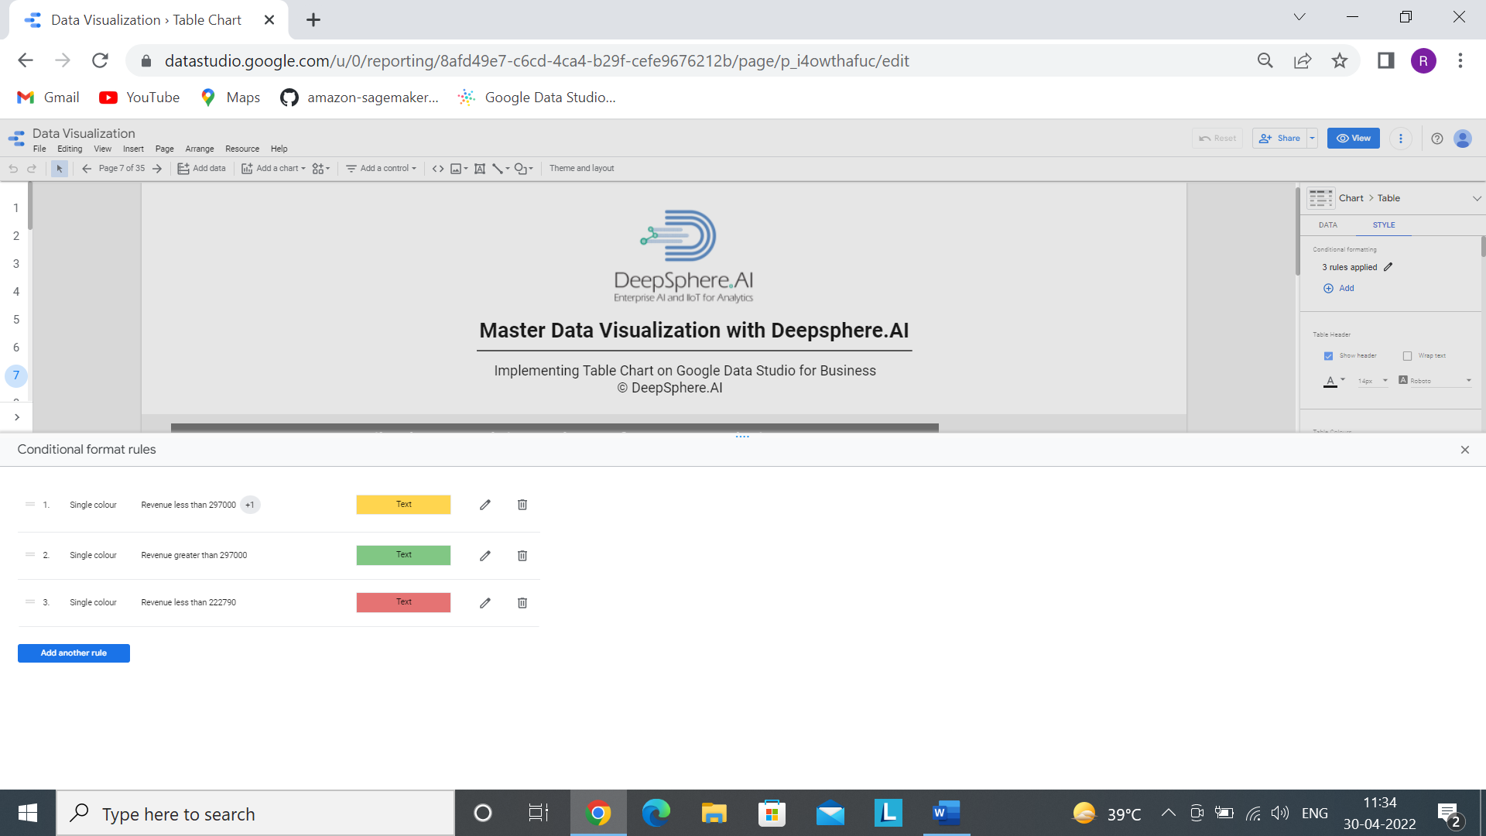

Step 5 Add the following filters

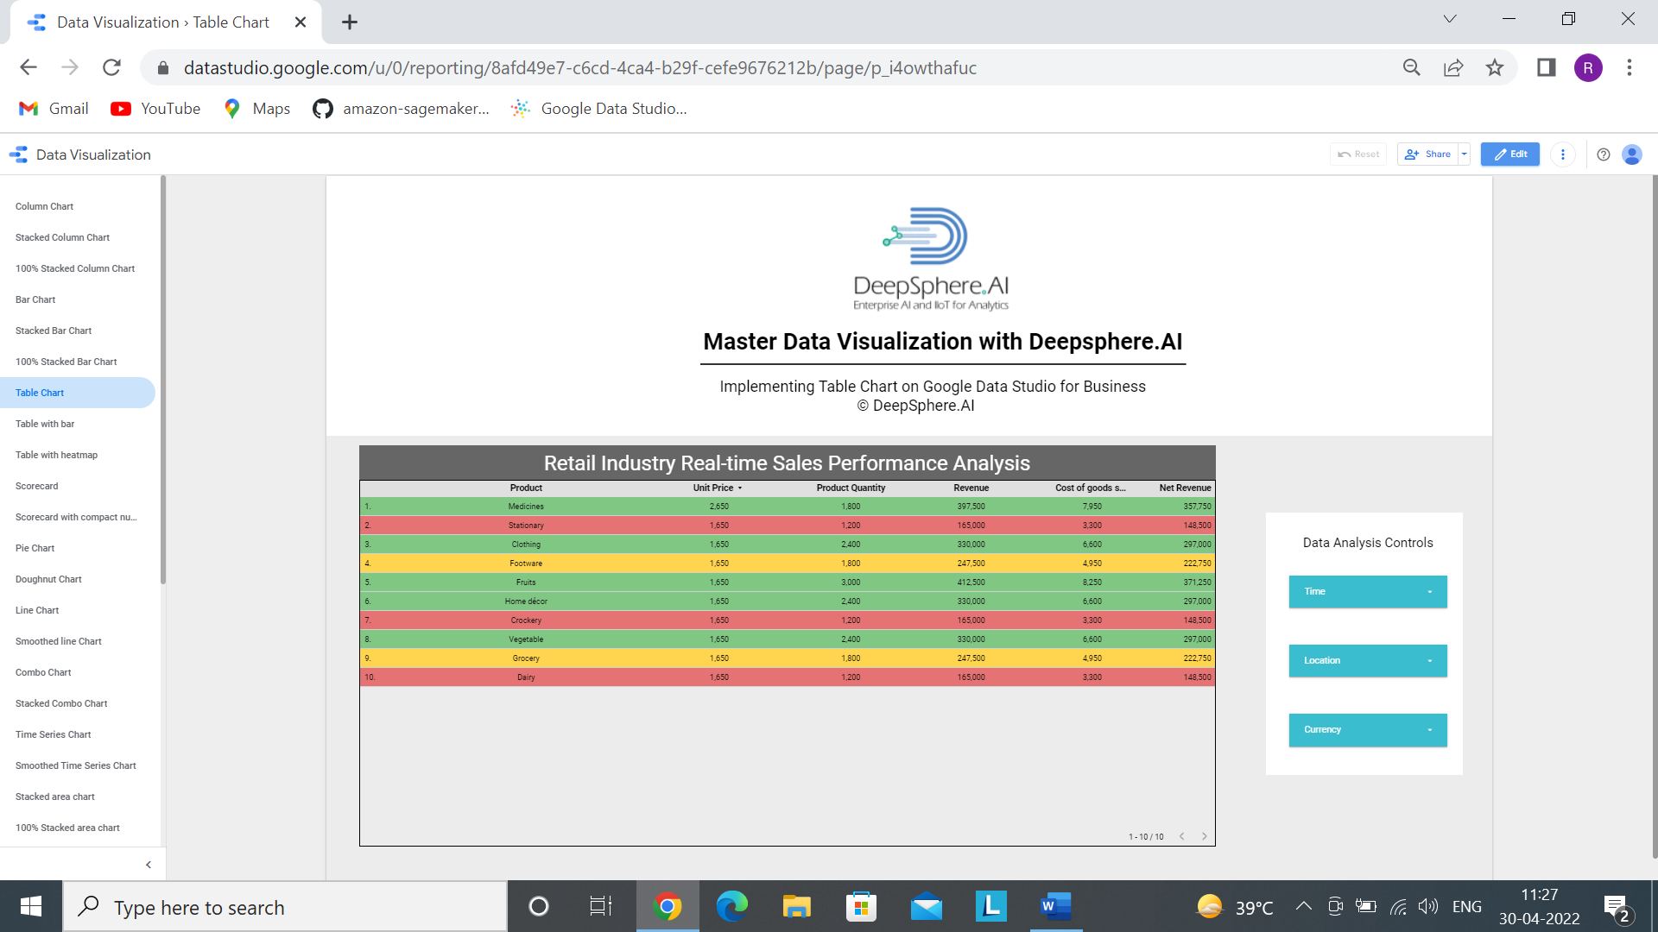

Add a control >>>>>>>>>> drop-down list

By following all the steps, we will get this



2.2 Table with bar

2.2.1- What is a Table with bar?

Ans- Tables display your data in a grid of rows and columns. Each column represents a dimension or metric, while each row is one record of your data.

2.2.2- When to use Table with bar?

Ans**- Tables is important if precise number is important.**

* If a company wants exact numeral data for analysis, then table is a great option.
* If a retail company wants exact amount of sales, Total expenditure etc. in a grid then table is used.

2.2.3- Does the Table with bar needs dimensions and metrics?

Ans- Yes, Table with bar needs both dimension and metrics, where we can add multiple dimensions and metrics based on our requirement. In this chart drill down option is enabled.

2.2.4- In the Table with bar, what is a dimension represents?

Ans- Dimensions are data categories. Dimension values (the data contained by the dimension) are names, descriptions or other characteristics of a category.

Add dimensions to the chart by dragging fields from the Available Fields panel on the right. You can also click Add dimension in the Data tab.

2.2.5- In the Table with bar, what is a metrics represents?

Ans- Metrics measure the things contained in dimensions and provide the numeric scale and data series for the chart.

Add metrics to the chart by dragging fields from the Available Fields panel on the right. You can also click **Add metric** in the Data tab.

Metrics are aggregations that come from the underlying data set, or are the result of implicitly or explicitly applying an aggregation function, such as COUNT(), SUM(), or AVG(). The metric itself has no defined set of values, so you can’t group by it, as you can with a dimension.

2.2.6- How does sample data look?

Ans-



2.2.7- How to develop a Table?

Ans- Step1- Add data to Report.



Step-2 Click on Add to Report



Step 3- Click on Add a Chart and select Table with bar.

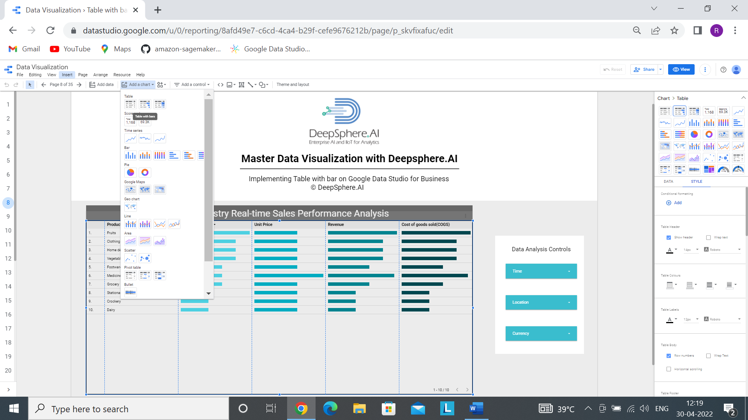

Step 4- Now after selecting a chart, we have to select proper dimension and metrics based on our requirement.

Here dimension is Product and the metric is Product quantity, cost of goods sold, Unit Price and Revenue.

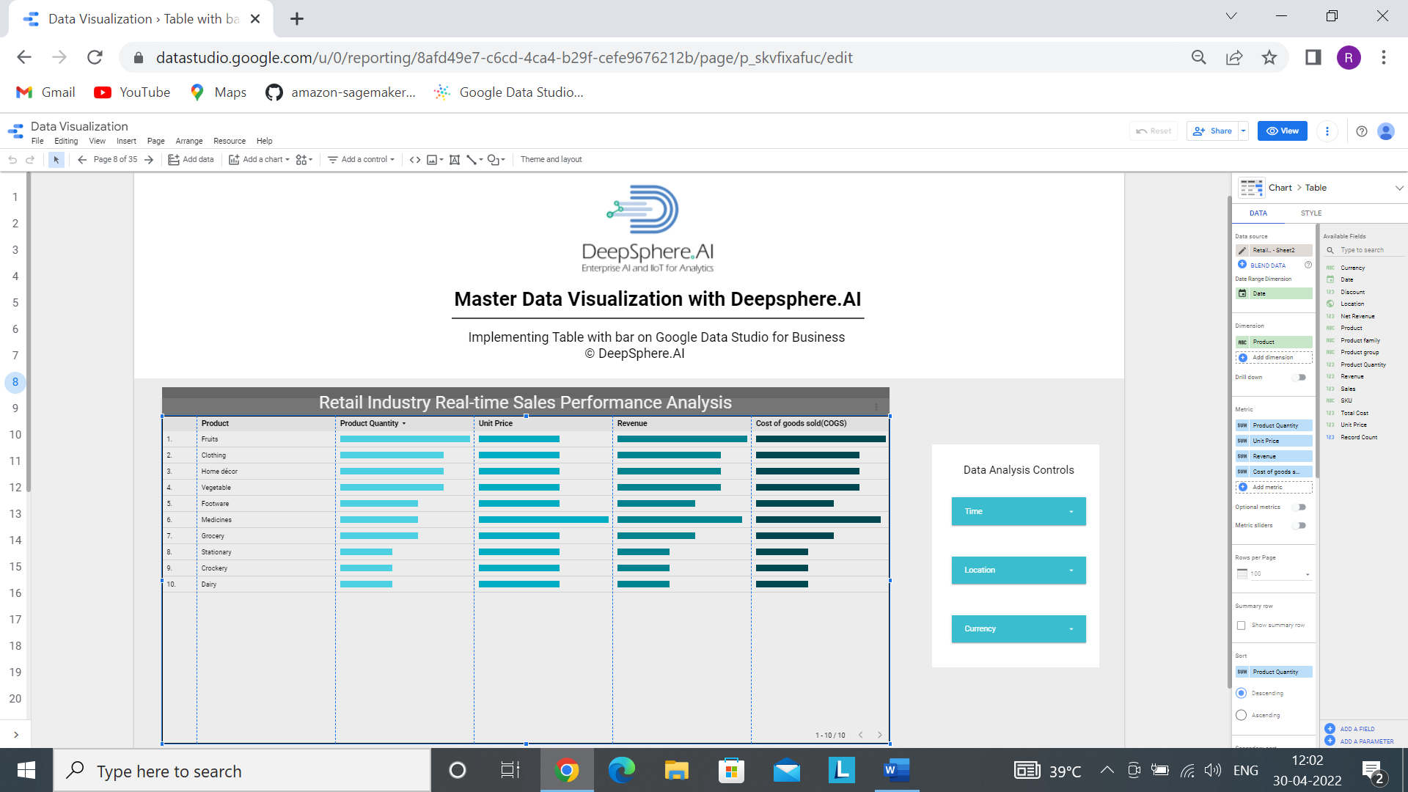

Step5- Based on the requirement, we can do the chart formatting.

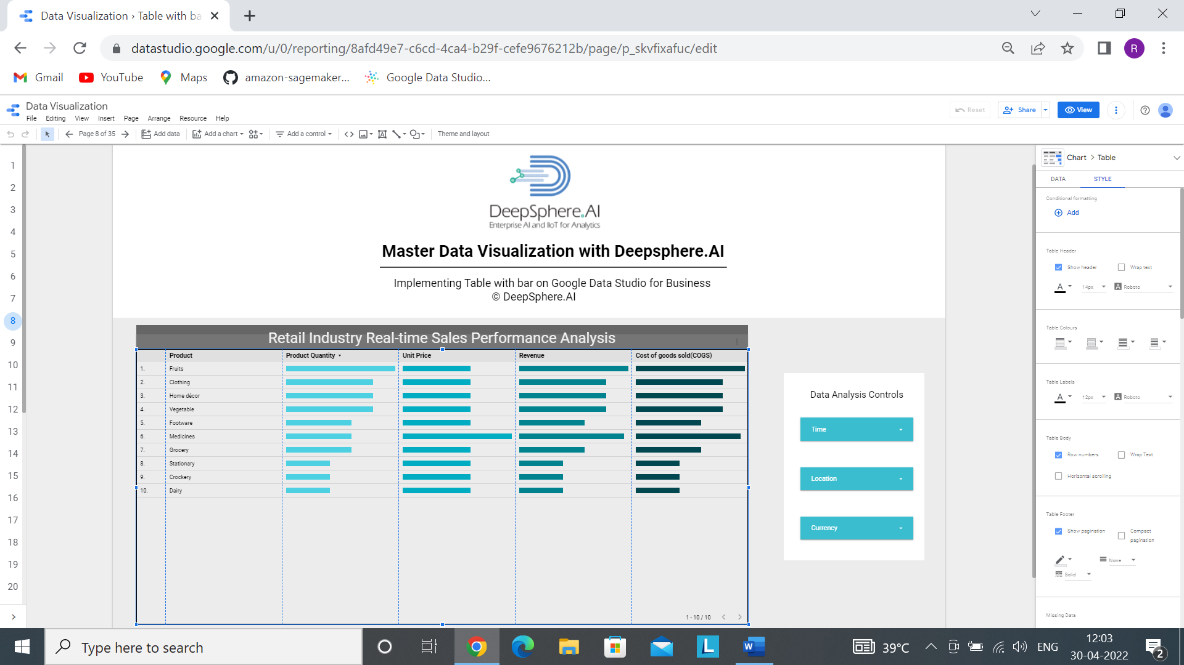

Step 5 Add the following filters



Add a control >>>>>>>>>> drop-down list

By following all the steps, we will get this

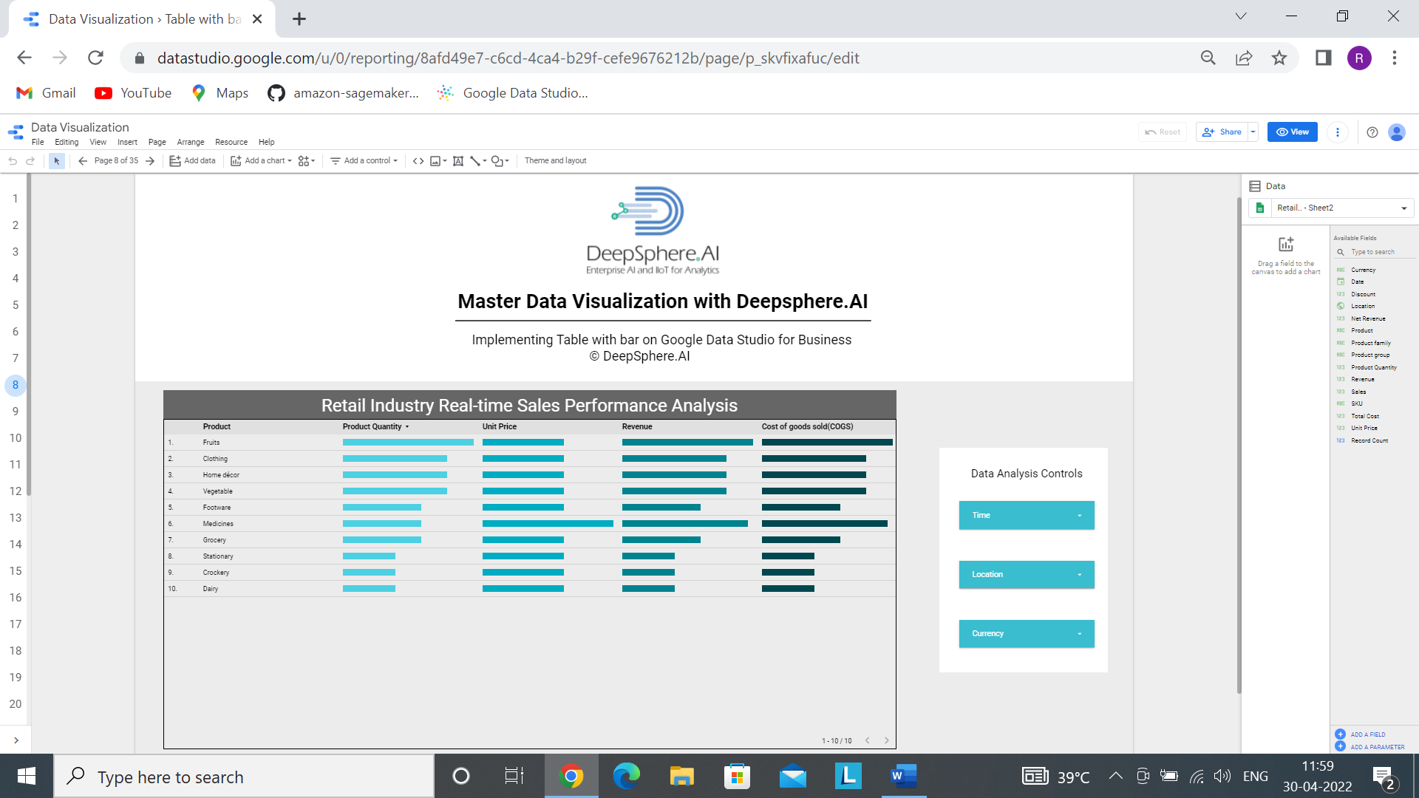

3. Scorecard

3.1 Scorecard

3.1.1- What is Scorecard chart?

Ans- Scorecards in Data Studio appear as numbers with the name of the metric. The format of the displayed number depends on how the metric is configured in data source

3.1.2- When to use Scorecard?

Ans**-** Scorecard is commonly used to highlight key performance indicators (KPIs) together with a change in their value over a specific baseline value.

3.1.3- Does the Scorecard needs dimensions and metrics?

Ans- Scorecard needs only metrics.

3.1.4- In the Scorecard, what is a dimension represents?

Ans- There is no dimension in Scorecard Chart.

3.1.5- In the Scorecard, what is a metrics represents?

Ans- Metrics measure the things contained in dimensions and provide the numeric scale and data series for the chart. Here, metrices are- Unit Price, Product Quantity and Revenue.

3.1.6- How does sample data look?

Ans-



3.1.7- How to develop a Scorecard?

Ans- Step1- Add data to Report.



Step-2 Click on Add to Report



Step 3- Click on Add a Chart and select Scorecard.

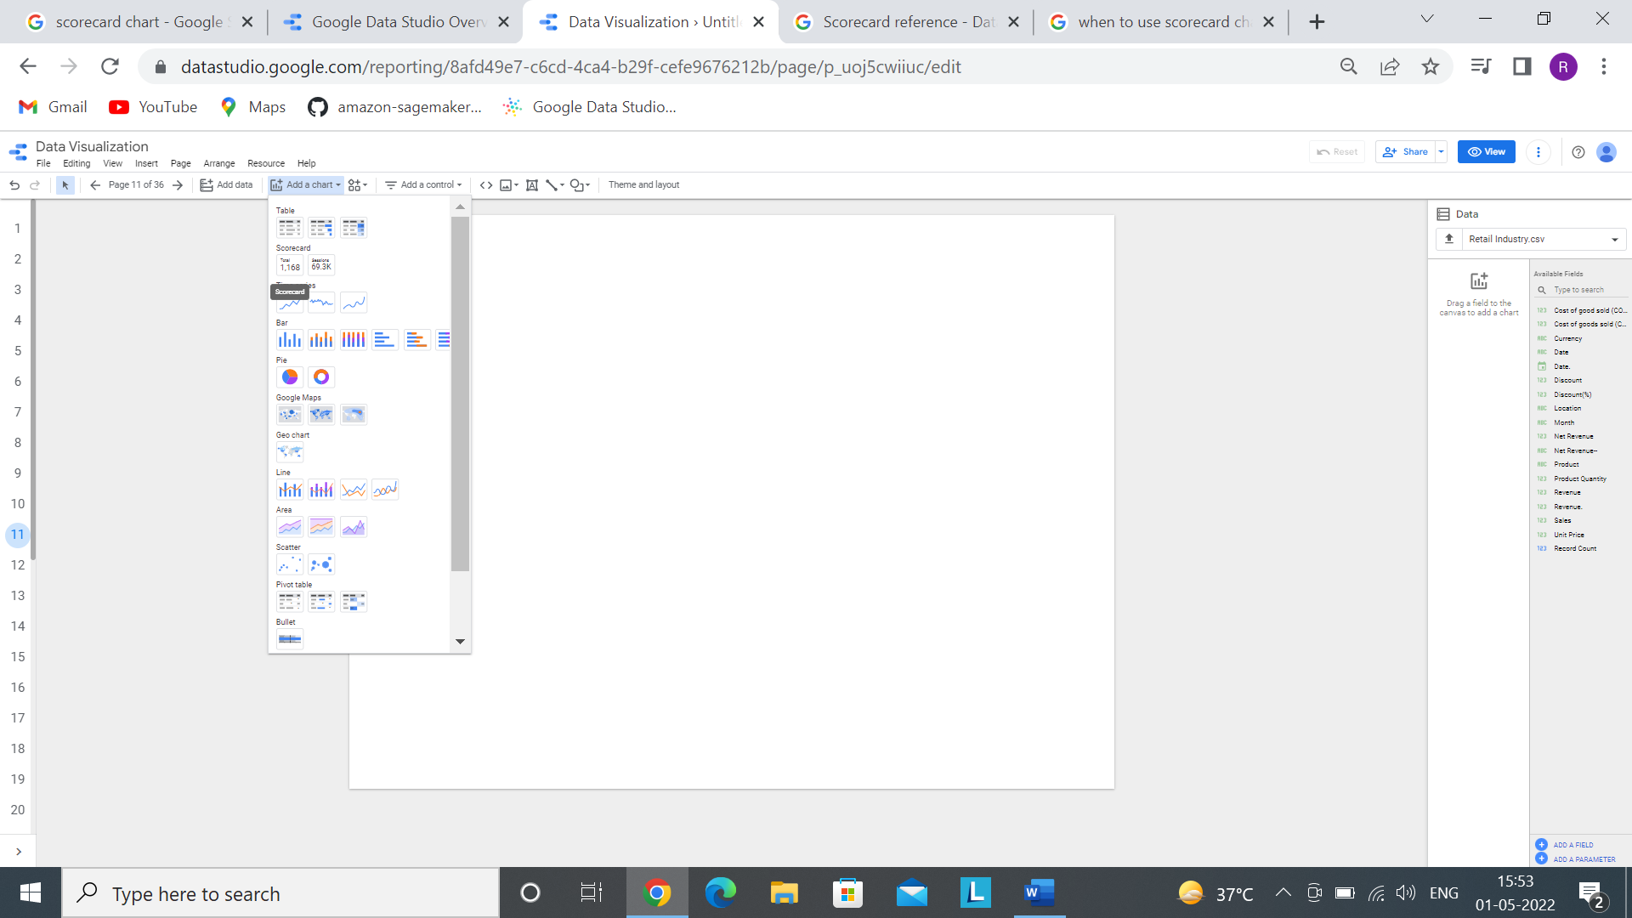

Step 4- Now after selecting a chart, we have to select proper metrics based on our requirement.

Here we created three different scorecard chart so selected metric are Unit Price, Product Quantity and Revenue.

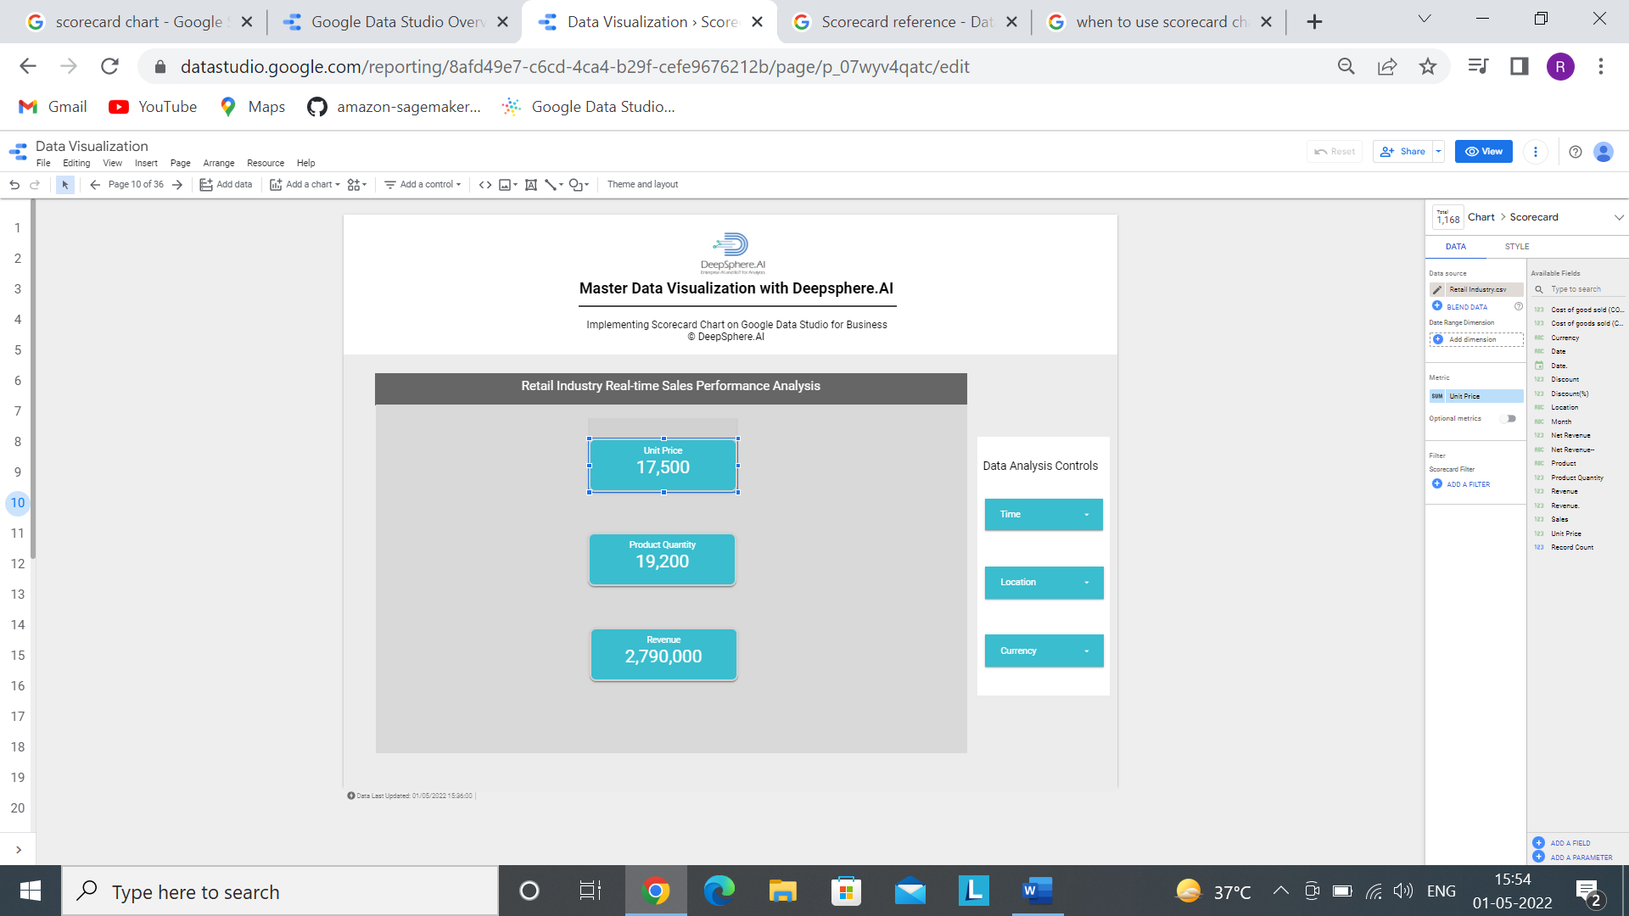 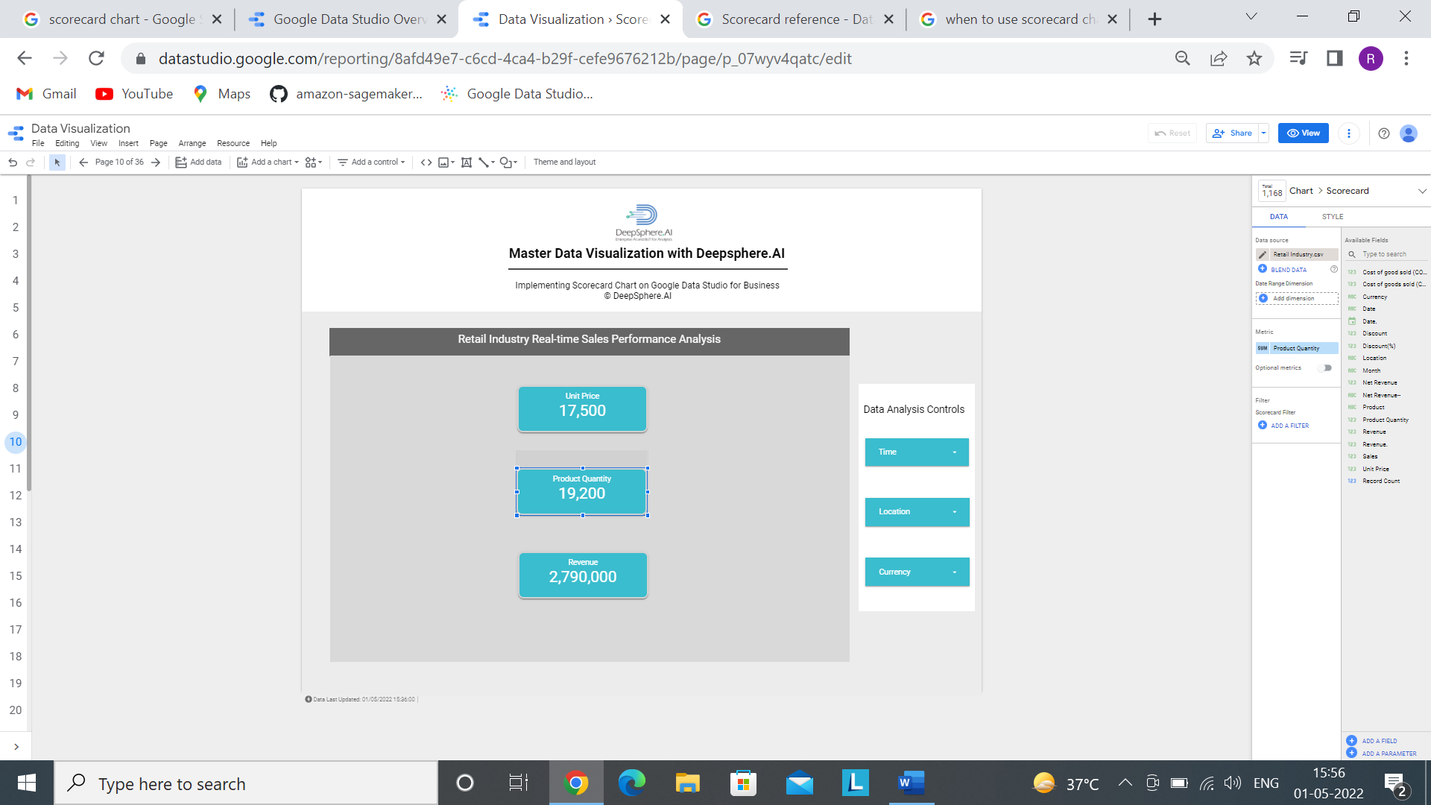 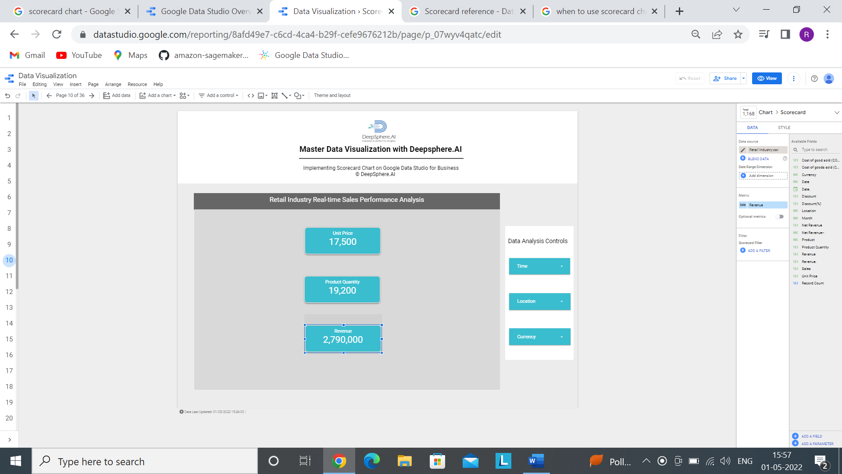

Step5- Based on the requirement, we can do the chart formatting.

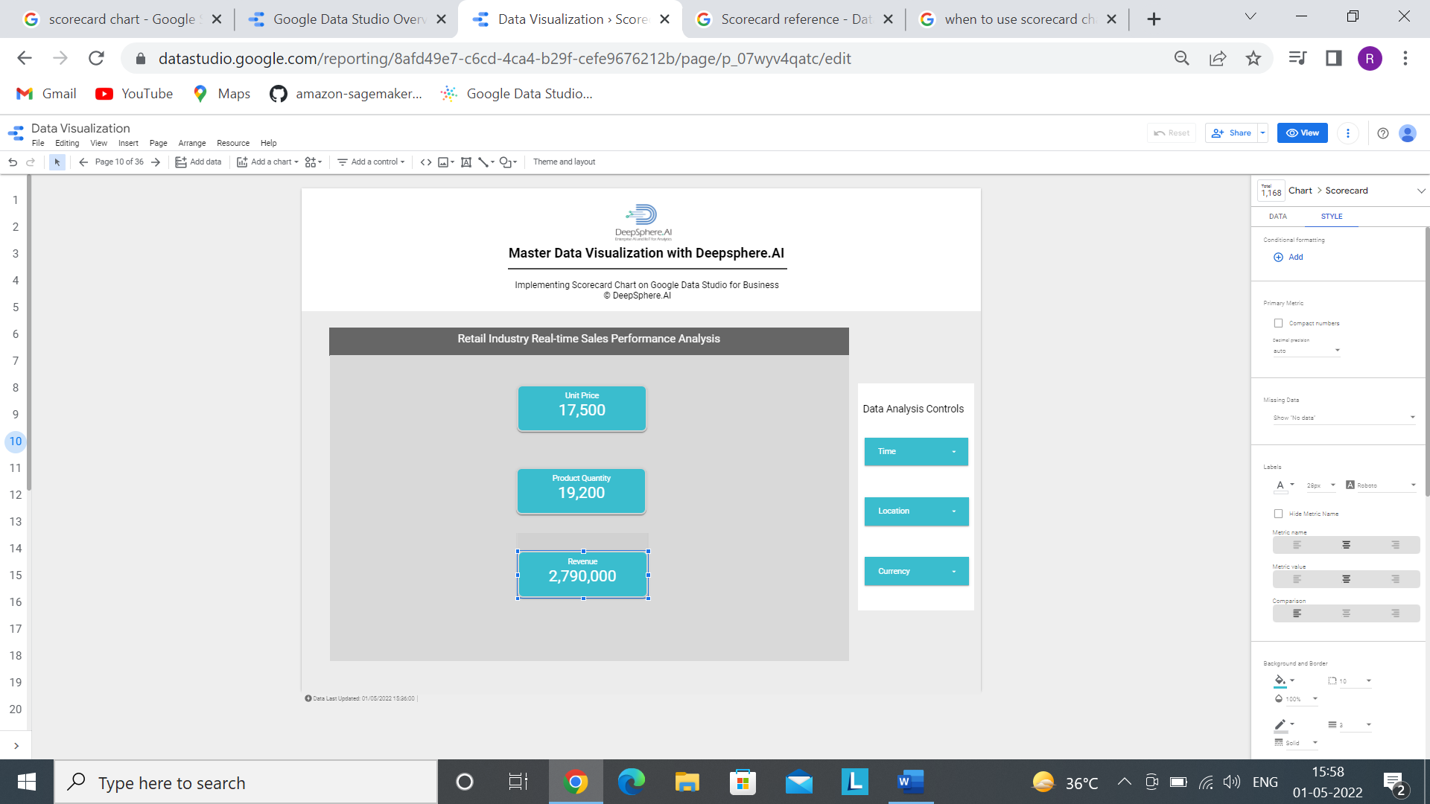

Step 5 Add the following filters



Add a control >>>>>>>>>> drop-down list

By following all the steps, we will get this

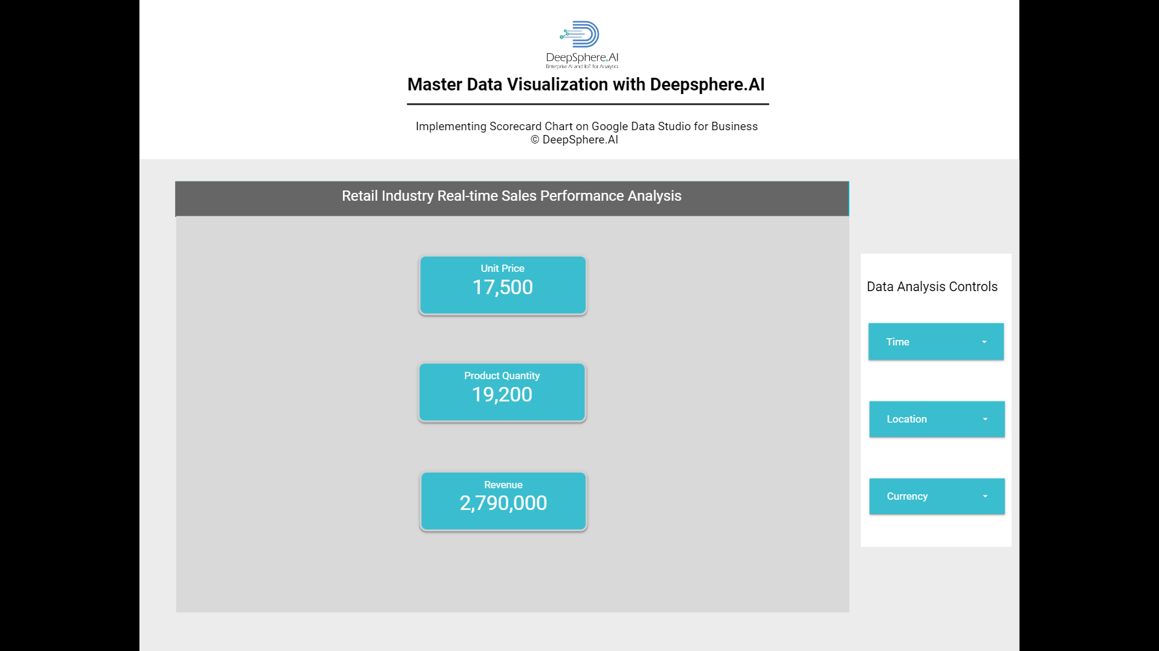

3.2 Scorecard with Compact Number

3.2.1- What is Scorecard with compact number chart?

Ans- Scorecard with compact number in Data Studio appear as compact numbers with the name of the metric. The format of the displayed compact number depends on how the metric is configured in data source

3.2.2- When to use Scorecard with compact number?

Ans**-** Scorecard with compact number is commonly used to highlight key performance indicators (KPIs) together with a change in their value over a specific baseline value.

3.2.3- Does the Scorecard with compact number needs dimensions and metrics?

Ans- Scorecard with compact number needs only metrics.

3.2.4- In the Scorecard with compact number, what is a dimension represents?

Ans- There is no dimension in Scorecard with compact number Chart.

3.2.5- In the Scorecard with compact number, what is a metrics represents?

Ans- Metrics measure the things contained in dimensions and provide the numeric scale and data series for the chart. Here, metrices are- Unit Price, Product Quantity and Revenue.

3.2.6- How does sample data look?

Ans-



3.2.7- How to develop a Scorecard with compact number?

Ans- Step1- Add data to Report.



Step-2 Click on Add to Report



Step 3- Click on Add a Chart and select Scorecard with compact number.



Step 4- Now after selecting a chart, we have to select proper metrics based on our requirement.

Here we created three different scorecard chart so selected metric are Unit Price, Product Quantity and Revenue.

  

Step5- Based on the requirement, we can do the chart formatting.



Step 5 Add the following filters



Add a control >>>>>>>>>> drop-down list

By following all the steps, we will get this

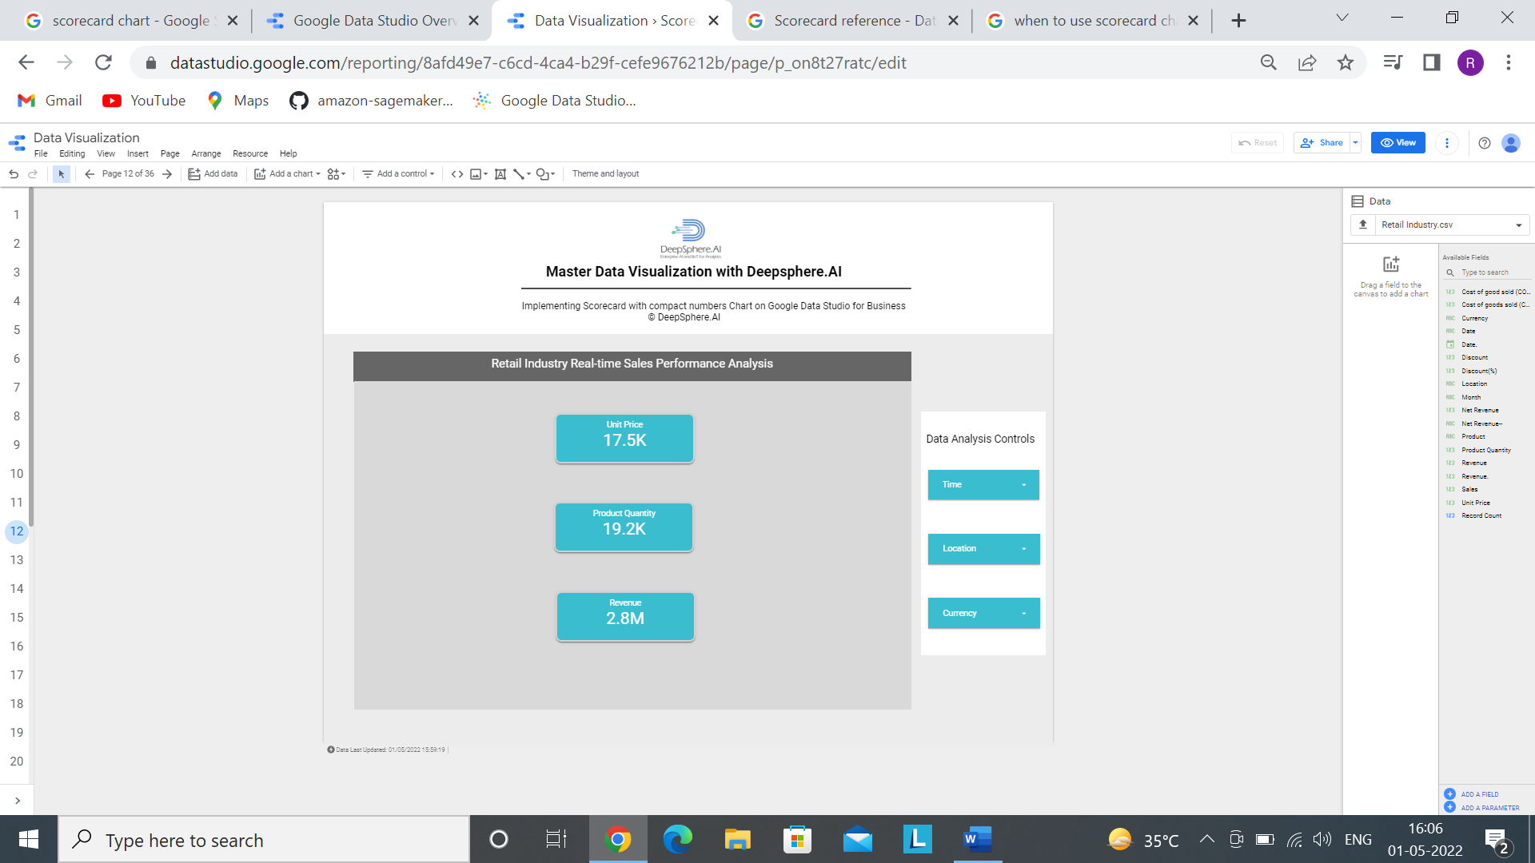

4. Pie

4.1 Pie Chart

4.1.1- What is Pie chart?

Ans- A pie chart is a circular statistical graphic, which is divided into slices to illustrate numerical proportion. In a pie chart, the arc length of each slice is proportional to the quantity it represents

3.2.2- When to use Pie chart?

Ans**-** Pie chart is used when we wanted to visualise the contribution of each product to the whole. Let’s understand this with a business scenario-

In a company, we want to see how much Revenue is generated by Dairy Product, Stationary etc. in a percentage to identify the best Product.

3.2.3- Does the Pie Chart needs dimensions and metrics?

Ans- Yes it needs 1 dimension and 1 metric.

3.2.4- In the Pie Chart, what is a dimension represents?

Ans- In the Pie Chart, dimension represents the field which we want to see in the circle or the field for which we want to have the visualization.

3.2.5- In the Pie Chart, what is a metrics represents?

Ans- In Pie Chart, metrics represents the value of dimension by which we get the slices and arc length depends on the value of metrics.

3.2.6- How does sample data look?

Ans-



3.2.7- How to develop a Scorecard with compact number?

Ans- Step1- Add data to Report.



Step-2 Click on Add to Report



Step 3- Click on Add a Chart and select Pie Chart.

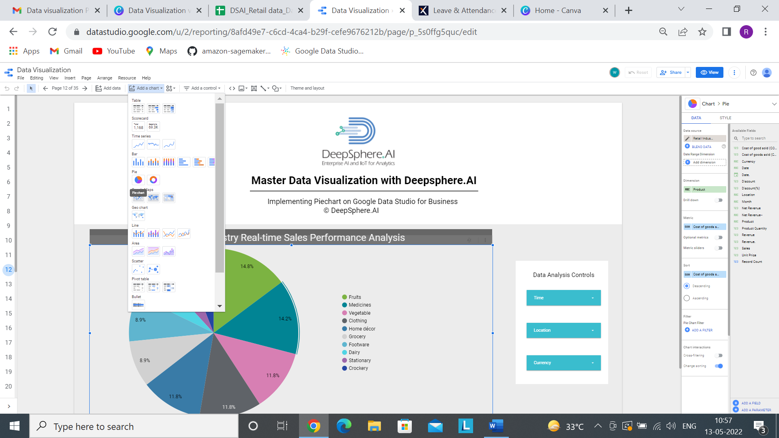

Step 4- Now after selecting a chart, we have to select dimension and metrics based on our requirement.

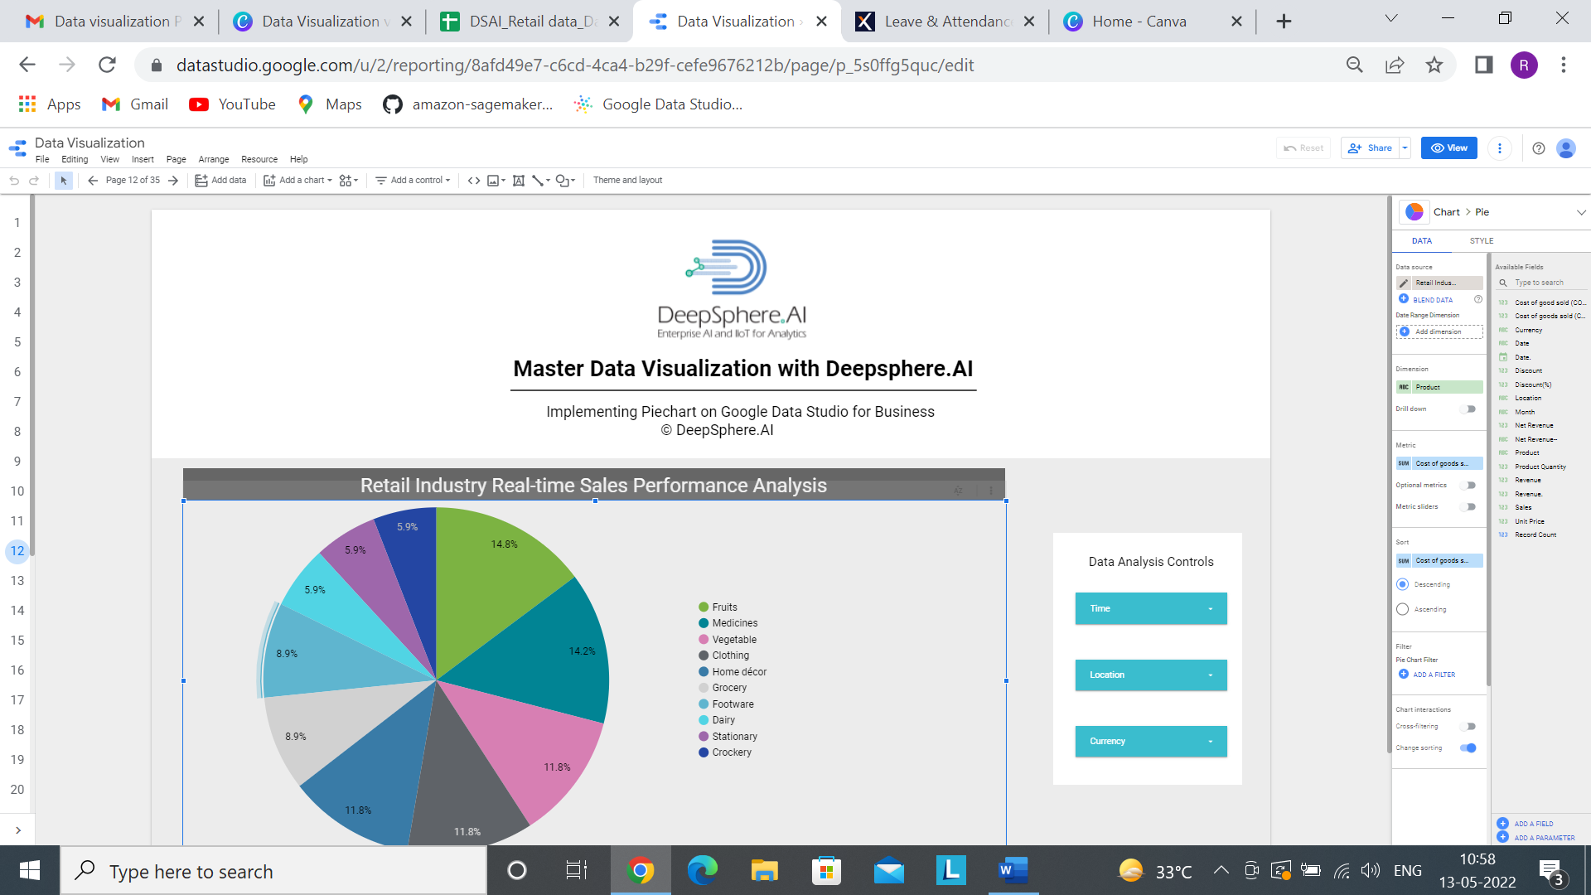

Step5- Based on the requirement, we can do the chart formatting.

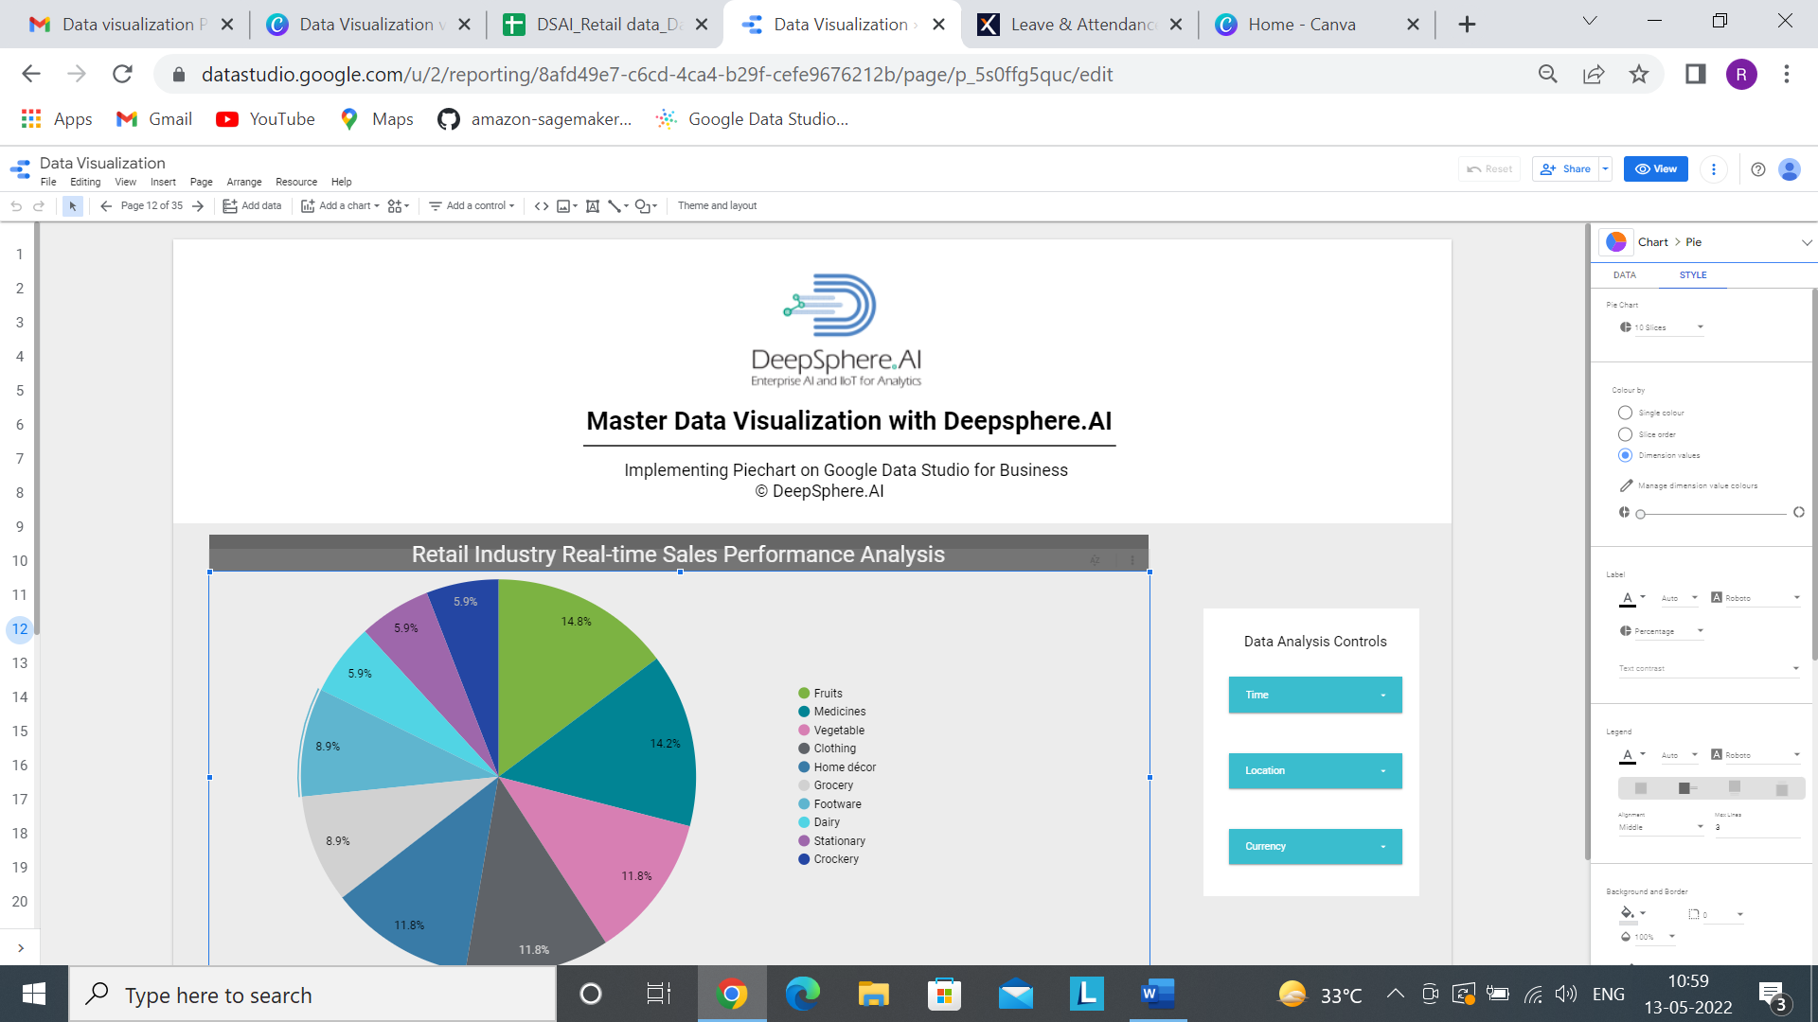

Step 5 Add the following filters



Add a control >>>>>>>>>> drop-down list

By following all the steps, we will get this

